1 October 2020
[136-20]

Supporting document 1

Safety assessment – Application A1202

Food derived from herbicide-tolerant and insect-protected corn line DP23211

Executive summary
Background
Application A1202 seeks approval for the sale and use of food derived from genetically modified (GM) corn line DP23211 that has tolerance to the herbicide glufosinate and is protected against the insect pest, corn rootworm.
Tolerance to glufosinate ammonium is achieved through expression of the enzyme phosphinothricin acetyltransferase (PAT) from the common soil bacterium Streptomyces viridochromogenes. DP23211 also expresses the phosphomannose isomerase (PMI) protein from Escherichia coli strain K-12. The PMI protein facilitates plant cell growth on media containing mannose and was used as a selectable marker following the transformation process. The PAT and PMI proteins have been assessed previously by FSANZ.
Protection against corn rootworm is conferred by the expression in the plant of two novel substances: the IPD072Aa protein (encoded by the ipd072Aa gene) from soil bacterium Pseudomonas chlororaphis and DvSSJ1, a double stranded RNA (dsRNA) that specifically silences the corn rootworm dvssj1 gene via RNA interference (RNAi). These novel substances cause intestinal epithelium damage specifically in corn rootworm larvae. The ipd072Aa gene and DvSSJ1 dsRNA have not previously been assessed by FSANZ.
This safety assessment addresses food safety and nutritional issues associated with the GM food. It therefore does not address:
• risks related to the environmental release of GM plants used in food production
• risks to animals that may consume feed derived from GM plants
• the safety of food derived from the non-GM (conventional) plant.
History of use
Corn is the world’s dominant cereal crop and has a long history of safe use in the food supply. Sweet corn is consumed directly while corn-derived products are routinely used in a large number and diverse range of foods, e.g. cornflour, starch products, breakfast cereals and high fructose corn syrup. Corn is also widely used as a livestock feed.
Molecular characterisation
The genes encoding PAT (mo-pat), PMI (pmi) and IPD072Aa (ipd072Aa) and the DNA fragments encoding DvSSJ1 dsRNA (dvssj1) were introduced into corn line DP23211 via two sequential transformations. The first transformation involved microprojectile bombardment of corn tissue to form a “landing pad” sequence at a specific location in the corn genome. The second transformation used Agrobacterium-mediated transformation to specifically integrate the mo-pat, pmi and ipd072Aa genes and DvSSJ1 fragments, and associated regulatory elements, into the landing pad.
Detailed molecular analyses of corn line DP23211 indicate that a single copy of the linked mo-pat, pmi, ipd072Aa and DvSSJ1 gene/fragment cassettes is present at a single insertion site in the genome. There are no extraneous plasmid sequences, nor antibiotic resistance marker genes, present in this line.
The introduced genetic elements were shown by molecular techniques and phenotypic analyses to be stably inherited across multiple generations. The pattern of inheritance supports the conclusion that the introduced traits occur within a single locus in the DP23211 genome and are inherited in accordance with Mendelian principles.
Characterisation and safety assessment of new substances
Newly expressed proteins
PAT and PMI are newly expressed proteins present in DP23211. They are expressed in various tissues including grain (4.3 and 3.9 µg/g dry weight, respectively), with the highest level of both proteins in pollen (54 and 33 µg/g dry weight, respectively). A range of characterisation studies confirmed the identity of PAT and PMI proteins in DP23211. The safety of these proteins has been assessed by FSANZ in numerous previous applications. Updated bioinformatic analyses undertaken for this application confirmed the expressed proteins are unlikely to be allergenic or toxic.
Corn line DP23211 also expresses the novel protein IPD072Aa. It is expressed throughout the plant, but is low in grain (1.8 µg/g dry weight). IPD072Aa expression is highest in root tissue (27 µg/g dry weight), which is the tissue corn rootworm larvae consumes. A range of characterisation studies confirmed the identity of the plant-expressed DP23211 and its equivalence with the corresponding protein produced in a bacterial expression system. Bioinformatic studies confirmed a lack of any significant amino acid sequence similarity to known protein toxins or allergens. Laboratory studies also demonstrated the IPD072Aa protein is susceptible to the action of digestive enzymes and would be thoroughly degraded before it could be absorbed during passage through the gastrointestinal tract. Additionally, oral exposure of IPD072Aa in mice did not show any evidence of acute toxicity. Taken together, the evidence supports the conclusion that IPD072Aa is not toxic or allergenic in humans.
DvSSJ1 dsRNA
In addition to three novel proteins, corn line DP23211 also contains a 210 bp dsRNA that is expressed in the plant and triggers RNAi in corn rootworm species. The 210 bp dsRNA is detectable in a variety of tissues in DP23211, its highest expression being in leaf (0.0708 μg/g dry weight) and its lowest expression in pollen and grain (0.00104 and 0.00314 μg/g dry weight, respectively). DvSSJ1 dsRNAs is specific to corn rootworms within the Diabrotica genus, i.e. Western, Northern and Southern corn rootworms.
There are no safety concerns regarding the presence of dsRNA molecules in DP23211. The available data do not indicate the dsRNA expressed in this line possess different characteristics, or is likely to pose a greater risk, than other RNAi mediators naturally present in corn.
Herbicide metabolites
For PAT, the metabolic profiles resulting from the novel protein/herbicide interaction have been established through a significant history of use. The glufosinate-tolerance trait is present in lines from over twenty previous applications to FSANZ. There are no concerns that the spraying of DP23211 with glufosinate ammonium would result in the production of metabolites that are not also produced in non-GM crops sprayed with the same herbicide and already used in the food supply.
Compositional analyses
Detailed compositional analyses were performed on DP23211. Analytes measured were proximates (protein, fat, ash, carbohydrates), fibre, amino acids, fatty acids, minerals, vitamins, anti-nutrients and secondary metabolites. Statistically significant differences were found between grain from DP23211 and the control for seven of the 69 analytes evaluated, however differences were small and all were within the range established for existing commercial non-GM corn varieties. Overall, the compositional data support the conclusion that there are no biologically significant differences in the levels of key constituents in grain from DP23211 compared to conventional non-GM corn varieties available on the market.
Conclusion
No potential public health and safety concerns have been identified in the assessment of herbicide-tolerant and insect-protected corn line DP23211. On the basis of the data provided in the present application, and other available information, food derived from DP23211 is considered to be as safe for human consumption as food derived from non-GM corn varieties.

Table of contents
Executive summary i
Index of Figures 3
Index of Tables 3
List of Abbreviations 3
1 Introduction 5
2 History of use 5
2.1 Host organism 5
2.2 Donor organisms 6
2.2.1 Streptomyces viridochromogenes 6
2.2.2 Escherichia coli 6
2.2.3 Pseudomonas chlororaphis 7
2.2.4 Diabrotica virgifera virgifera 7
2.2.5 Other organisms 7
3 Molecular characterisation 7
3.1 Transformation Method 7
3.2 Detailed description of inserted DNA 8
3.2.1 PHP56614 9
3.2.2 PHP74643 10
3.3 Development of the corn line from original transformation 14
3.4 Characterisation of the inserted DNA and site(s) of insertion 14
3.4.1 Identifying the number of integration sites 14
3.4.2 Detection of backbone sequence 15
3.4.3 Stability of the genetic changes in corn line DP23211 15
3.4.4 Insert integrity and site of integration 16
3.4.5 Open reading frame analysis 16
3.4.6 Conclusion 17
4 Characterisation and safety assessment of novel substances 17
4.1 Newly expressed proteins 17
4.1.1 PMI 18
4.1.2 PAT 20
4.1.3 IPD072Aa 23
4.2 Newly expressed dsRNA 28
4.2.1 DvSSJ1 dsRNA 28
4.3 Novel herbicide metabolites in GM herbicide-tolerant plants 30
5 Compositional analysis 30
5.1 Key Components 30
5.2 Study design 30
5.3 Analyses of key components in grain 32
5.3.1 Proximates and fibre 32
5.3.3 Amino acids 32
5.3.3 Fatty acids 33
5.3.4 Minerals 34
5.3.5 Vitamins 35
5.3.6 Anti-nutrients and Secondary Metabolites 36
5.4 Conclusion 36
6 Nutritional impact 37
7 References 38
8 Appendix 1 44
9 Appendix 2 45

Index of Figures
 | Title | Page
Figure 1 | Plasmid-derived genetic elements present in DP23211 | 8
Figure 2 | Inserted DNA from PHP56614 | 9
Figure 3 | Inserted DNA from PHP74643 | 10
Figure 4 | Deduced amino acid sequence of the PMI protein | 18
Figure 5 | Stages of corn growth | 19
Figure 6 | Deduced amino acid sequence of the PAT protein encoded by pat and mo-pat genes | 21
Figure 7 | Deduced amino acid sequence of IPD072Aa | 23
Figure 8 | N-terminal amino acid sequences of DP23211- and E. coli-derived IPD072Aa | 24

Index of Tables
 | Title | Page
Table 1 | PHP56614-derived landing pad genetic elements in the intermediary line | 10
Table 2 | PHP74643-derived genetic elements present in DP23211 | 12
Table 3 | DP23211 generations used for various analyses | 14
Table 4 | Segregation results in five generations of DP23211 | 16
Table 5 | Expression of PMI (µg/g DW) in various tissues | 19
Table 6 | Expression of PAT (µg/g DW) in various tissues | 22
Table 7 | Expression of IPD072Aa (µg/g DW) in various tissues | 25
Table 8 | Bioactivity of heat-treated IPD072Aa in a diet fed to WCR | 27
Table 9 | Concentration of DvSSJ1 dsRNA (µg/g DW) in various tissues | 29
Table 10 | Analytes measured in the grain samples | 32
Table 11 | Comparison of proximates and fibre | 32
Table 12 | Comparison of amino acids (% DW) | 33
Table 13 | Comparison of fatty acids (% total fatty acids) | 34
Table 14 | Comparison of minerals (% DW) | 35
Table 15 | Comparison of vitamins (mg/kg DW) | 35
Table 16 | Comparison of anti-nutrients and secondary metabolites | 36
Table 17 | Summary of statistically significant (raw P value) compositional differences between control and DP23211 | 37

List of Abbreviations
Abbreviation | Description
ATP | adenosine triphosphate
BLOSUM | BLOcks SUbstitution Matrix
bp | base pair
BW | bodyweight
COMPARE | COMprehensive Protein Allergen REsource
DNA | deoxyribonucleic acid
dsRNA | double stranded RNA
dvssj1 gene | smooth septate junction protein 1 gene from Diabrotica virgifera virgifera
DW | dry weight
ELISA | enzyme-linked immunosorbent assay
FASTA | fast alignment search tool – all
FDR | false discovery rate
FSANZ | Food Standards Australia New Zealand
g | gram
GM | genetically modified
HDR | Homology-directed repair
HFCS | High Fructose Corn Syrup
ILSI | International Life Sciences Institute
kDa | kilodalton
LLOQ | lower limit of quantification
Min | minutes
mRNA | messenger RNA
MT | million tons
ND | not detectable
NGS | Next Generation Sequencing
ng | nanogram
nt | nucleotide
OECD | Organization for Economic Co-operation and Development
OGTR | Office of the Gene Technology Regulator
ORF | open reading frame
PAT | phosphinothricin acetyltransferase
PCR | polymerase chain reaction
PPT | phosphinothricin
RNA | ribonucleic acid
SbS | Southern-by-Sequencing
SDS-PAGE | sodium dodecyl sulfate polyacrylamide gel electrophoresis
SGF | simulated gastric fluid
SIF | simulated intestinal fluid
SNPs | single nucleotide polymorphisms
SSI | site specific integration
SSJ | smooth septate junction
WCR | western corn rootworm
μg | microgram
US | United States
USDA | United States Department of Agriculture
UTR | untranslated region

1 Introduction
Dow AgroSciences Australia Pty Ltd, a member of the Corteva Agriscience group of companies, submitted an application to FSANZ to vary Schedule 26 in the Australia New Zealand Food Standards Code (the Code). The variation is to include food from a new genetically modified (GM) corn line DP23211, with OECD Unique Identifier DP-Ø23211-2 (herein referred to as DP23211). This corn line has been genetically modified to have tolerance to the herbicide glufosinate and be protected against the insect pest, corn rootworm.
Tolerance to herbicides containing glufosinate is achieved with the expression of the phosphinothricin acetyltransferase (PAT) protein, encoded by the maize optimised mo-pat gene from the bacterium Streptomyces viridochromogenes. The PAT protein acetylates the free amino group of glufosinate to produce the herbicidally-inactive metabolite, 2-acetamido-4-methylphosphinico-butanoic acid (N-acetyl glufosinate). The PAT protein has been assessed by FSANZ in over twenty previous applications and globally is represented in six major crop species and over thirty approved single GM plant events (CERA 2011).
DP23211 contains the phosphomannose isomerase (pmi) gene, which is derived from Escherichia coli strain K-12. Expression of the PMI protein allows plant cells to use mannose as a carbon source (Reed et al., 2001; Negrotto et al., 2000). This was used as a selectable marker to assist with identification of transformed plant cells in the early stages of selection. The PMI protein has been previously assessed by FSANZ in four corn applications - A564 (FSANZ 2006), A580 (FSANZ 2008b), A1001 (FSANZ 2008a), A1060 (FSANZ 2012) and one rice application – A1138 (FSANZ 2017)
Protection from corn rootworm is achieved by expression of the IPD072Aa protein, encoded by the ipd072Aa gene from soil bacterium Pseudomonas chlororaphis. Corn rootworm protection is also achieved by introducing DNA sequences in which the expressed dsRNA silence the expression of a gene in western corn rootworm (WCR; Diabrotica virgifera virgifera) using a mechanism known as RNA interference or RNAi (Hannon, 2002). The introduced DNA sequences are derived from the smooth septate junction protein 1 (dvssj1) gene from D. virgifera. FSANZ has previously approved a large number of applications where insect-protection in crops was provided by the introduction of Bacillus thuringiensis Cry proteins. This is the first application where insect protection is based on the IPD072Aa protein and DvSSJ1 dsRNA.
If approved, food derived from DP23211 corn line may enter the Australian and New Zealand food supply as imported food products.

2 History of use

2.1 Host organism
Corn (Zea mays) is also referred to as maize and has been cultivated for human consumption and other uses for thousands of years (Ranum et al., 2014). It has been studied extensively due to its economic importance in many industrialised countries of the world. For more detailed information please refer to detailed reports published by the Organisation for Economic Cooperation and Development (OECD 2002), the Grains Research & Development Corporation (GRDC 2017) and the Office of the Gene Technology Regulator (OGTR, 2008).
Corn is grown worldwide and is the world’s dominant cereal crop (2018/19 = 1,125 MT) ahead of wheat (731 MT) and rice (499 MT) (USDA 2019). The United States and China are the largest producers and in 2018/19 production reached 366 and 257 MT, respectively. Corn is not a major crop in Australia or New Zealand and in 2018, production was approximately 0.387 and 0.192 MT, respectively (FAOSTAT 2018). It is estimated that around 92% of all corn planted in the US is GM while in Canada, the estimate of GM corn is approximately 80% of total corn. No GM corn is currently grown commercially in Australia or New Zealand.
The limited domestic production of corn in Australia and New Zealand is supplemented by importing corn grain and corn-based products that are used widely in processed foods. Imports to Australia and New Zealand in 2018 included approximately 8,530 and 2,136 tonnes respectively of corn flour and 1,543 and 248 tonnes respectively of corn oil (FAOSTAT 2018). Neither Australia nor New Zealand currently produce fructose, either crystalline or as high fructose corn syrup (HFCS). About 3,000 tonnes of crystalline fructose were imported into Australia in 2011 (Green Pool 2012).
The majority of grain and forage derived from corn is used as animal feed, however corn also has a long history of safe use as food for human consumption. Human food products include corn starch, flour, oil and HFCS. In Australia and New Zealand, corn starch is used in dessert mixes and canned foods and HFCS is used in breakfast cereals, baking products, corn chips and extruded confectionary.

2.2 Donor organisms

2.2.1 Streptomyces viridochromogenes
The source of the mo-pat gene is the bacterium species S. viridochromogenes. This bacterium is Gram-positive, spore-forming, found in soil and water and is not pathogenic to humans. Although there is no evidence of S. viridochromogenes use in the food industry, the pat gene has been used to confer tolerance to glufosinate ammonium herbicides in food producing crops for over two decades (CERA, 2011).

2.2.2 Escherichia coli
The source of the selectable marker gene, pmi, is the bacterium E. coli. This bacterium is Gram-negative and facultative anaerobic. Members of the genus Escherichia are ubiquitous in the environment and are normally found in the digestive tracts of vertebrates, including humans. The vast majority of E. coli strains are harmless to humans, although some pathogenic strains of E. coli can cause diarrhoea and occasionally urinary tract infections.
Strains of E. coli, such as the enterohaemorrhagic E. coli group (e.g. 0157:H7), are particularly virulent pathogenic strains responsible for causing serious food-borne illness. This particular group of pathogenic E. coli are distinct from the strains of E. coli (the K-12 strains) that are used routinely in laboratory manipulations. The E. coli used as a donor organism for the pmi gene in this application is K-12.
The K-12 strains of E. coli have a long history of safe use and are commonly used as protein production systems in many commercial applications, including for pharmaceutical products (Baeshen et al., 2015) and food ingredients (e.g. Schedule 18 of the Code permits the use of chymosin derived from E. coli K-12 strain as a food processing aid).

2.2.3 Pseudomonas chlororaphis
The source of the ipd072Aa gene is P. chlororaphis (Schellenberger et al., 2016). This bacterium is Gram-negative, aerobic, found in soil and is not pathogenic to humans. The bacterium has a history of safe use in agriculture and in food and feed crops (Arrebola et al., 2019).

2.2.4 Diabrotica virgifera virgifera
The DvSSJ1 DNA fragments are derived from a portion of the dvssj1 gene from WCR (D. virgifera, Coleoptera order, Chrysomelidae Family), a beetle that is native to North America but has spread to Europe (Mrganić et al., 2018). This insect is a member of the corn rootworm complex that also includes the northern corn rootworm (D. barberi) and southern corn rootworm (D. undecimpuntata). The insect larvae feed on corn roots causing physiological damage to plants as a result of impaired water/nutrient absorption and harvesting difficulties as a result of plant lodging (the bending over of the stems near ground level). It is regarded as one of the most damaging insects to corn in the US. There are no reports of any direct effects of the insect on humans.

2.2.5 Other organisms
Genetic elements from several other organisms have been used in the genetic modification of DP23211 (refer to Table 1 and 2). These genetic elements are non-coding sequences and are used to regulate the expression of the new genes.

3 Molecular characterisation
Molecular characterisation is necessary to provide an understanding of the genetic material introduced into the host genome and helps to frame the subsequent parts of the safety assessment. The molecular characterisation addresses three main aspects:
- the transformation method together with a detailed description of the DNA sequences introduced to the host genome
- a characterisation of the inserted DNA, including any rearrangements that may have occurred as a consequence of the transformation
- the genetic stability of the inserted DNA and any accompanying expressed traits.

3.1 Transformation Method
In order to create DP23211, two sequential transformations were performed on the proprietary inbred PHR03 corn line. The first transformation integrated sequences from plasmid PHP56614 to generate an intermediary line. The intermediary line was then subjected to a second transformation to integrate sequences from plasmid PHP74643 and generate the DP23211 corn line. The methodology is outlined in the flowchart in Appendix 1 and summarised below.
The first transformation involved microprojectile bombardment of corn tissue with PHP56614 (Appendix 2) and two additional plasmids that were not intended for recombination (PHP21139 and PHP31729). Plasmid PHP56614 was used to insert an integration site sequence (also referred to as a “landing pad” sequence) at a specific location in the corn genome. The purpose of the co-bombardment of PHP21139 and PHP31729 plasmids was to transiently express corn-derived WUS and ODP2 proteins, found within these plasmids respectively, to improve the regeneration of corn plants following the transformation process (Lowe et al., 2016; Gordon-Kamm et al., 2013).
The second transformation used Agrobacterium-mediated transformation with plasmid PHP74643 (Appendix 2). Site-specific integration (SSI) of PHP74643-derived DNA into the landing pad introduced the pmi, mo-pat and ipd072Aa gene cassettes and the DvSSJ1 fragment cassette. The zm-wus2, zm-odp2, mo-Flp and DsRed2 genes on the PHP74643 plasmid were not integrated into the corn genome but were transiently expressed. WUS and ODP2 proteins allowed for improved regeneration, FLP recombinase allowed the SSI of DNA (see section 3.2.2) and DsRed2 allowed the developer to screen for any unintended integration of DNA sequences in plant cells. Selection using the PMI selectable marker, by growing transformed plant cells on media containing mannose, was only applicable following the second transformation step.
Following both transformation steps regenerated plants were screened using a Next Generation Sequencing (NGS) method known as Southern-by-Sequencing (SbSTM). Plants with the intended insertion and no unintended DNA sequences were selected. Following the evaluation of trait efficacy and agronomic performance, corn line DP23211 was selected.

3.2 Detailed description of inserted DNA
The sequential two-step transformation process results in corn line DP23211 that contains inserted DNA sequences from two distinct plasmids (Figure 1). Each plasmid is described below.
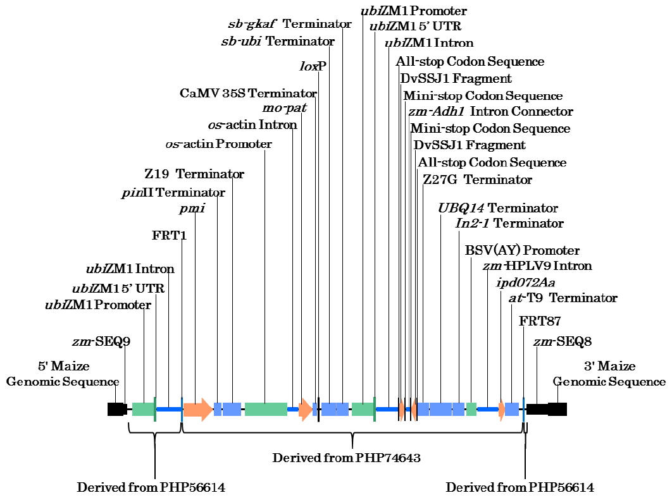
Figure 1. Plasmid-derived genetic elements present in DP23211

3.2.1 PHP56614
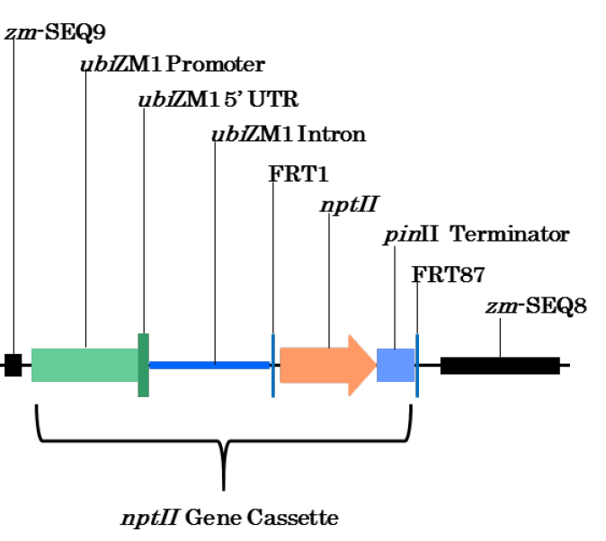
Only the sequence between zm-SEQ9 and zm-SEQ8 of the PHP56614 plasmid were intended for incorporation into the corn genome. This sequence is referred to as the “landing pad”. A representation of the landing pad region that was incorporated into the intermediary line during the first transformation step is shown in Figure 2. This maps the location of each of the genetic elements, of which further information can be found in Table 1.
Figure 2. Inserted DNA from PHP56614
The zm-SEQ9 and zm-SEQ8 sequences are homologous to corn genomic sequences and allow the transfer of the landing pad sequence to a specific location in the corn genome. Within the landing pad is a neomycin phosphotransferase II (nptII) gene cassette under the control of an endogenous promoter, 5’UTR and intron from the ubiquitin gene 1 (ubiZM1; Christensen et al., 1992) and a terminator sequence from the Solanum tuberosum (potato) proteinase inhibitor II gene (pinII; An et al., 1989; Keil et al., 1986).
nptII from E. coli is a commonly used selectable marker in the production of GM plants (OGTR, 2012) and is removed from the intermediary line in the subsequent transformation step. This removal is based on two flippase recombination target sites, FRT1 and FRT87, either side of the nptII gene and pinII terminator. These sequences allow the PHP56614-derived DNA to act as a landing pad for SSI in the next transformation step (see Section 3.2.2)
Outside of the landing pad sequence, the PHP56614 plasmid contains sequences not intended for insertion into the corn genome (Appendix 2). The I-CreI endonuclease gene cassette is one of these sequences and the I-CreI endonuclease is transiently expressed following transformation. This enzyme creates a double-stranded break between the continuous and endogenous zm-SEQ9 and zm-SEQ8 sequences in the corn genome. In a natural cellular mechanism known as homology-directed repair (HDR) (Jasin & Rothstein, 2013), the zm-SEQ9 and zm-SEQ8 sequences in the genome and the same sequences in PHP56614 cross over, introducing the landing pad sequence. The remaining sequences in PHP56614 are not incorporated into the intermediary line but are used for standard molecular biology techniques such as preparing the plasmid or passaging through standard laboratory bacteria.
Table 1: PHP56614-derived landing pad genetic elements in the intermediary line
Genetic element | Source | Description, Function & Reference | Present in DP23211
Zm-SEQ9 | Zea mays | Endogenous sequence and genomic recognition site for HDR | Yes
ubiZM1 promoter | Zea mays | Promoter region from the Zea mays ubiquitin gene 1 (Christensen et al., 1992) | Yes
ubiZM1 5’UTR | Zea mays | 5’ untranslated region (UTR) from the Zea mays ubiquitin gene 1 (Christensen et al., 1992) | Yes
ubiZM1 intron | Zea mays | Intron region from the Zea mays ubiquitin gene 1 (Christensen et al., 1992) | Yes
FRT1 | Saccharomyces cerevisiae | Flippase recombination target site (Proteau et al., 1986) | Yes
nptII | Escherichia coli | Selectable marker used in plant transformations (OGTR, 2012) | No *
pinII terminator | Solanum tuberosum | Terminator sequence from the proteinase inhibitor II gene (An et al., 1989; Keil et al., 1986) | No *
FRT87 | Saccharomyces cerevisiae | Flippase recombination target site (Proteau et al., 1986) | Yes
Zm-SEQ8 | Zea mays | Endogenous sequence and genomic recognition site for HDR | Yes
* replaced during SSI

3.2.2 PHP74643
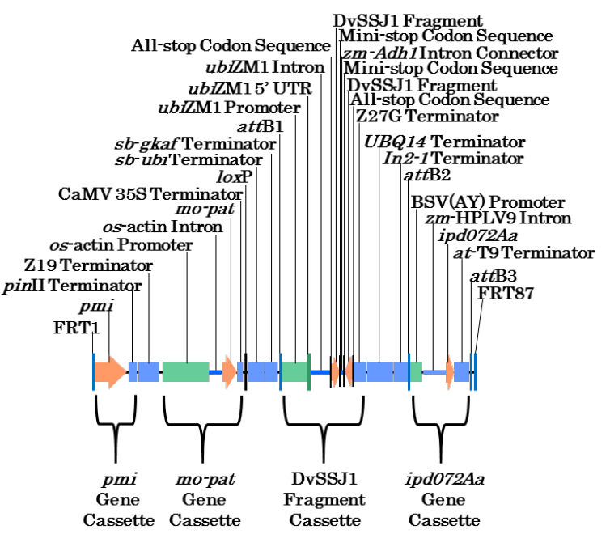
Only the sequence between FRT1 and FRT87 of the PHP74643 plasmid is intended for incorporation into the corn genome. A representation of the region that was inserted into the landing pad of the intermediary line during the second transformation step is shown in Figure 3. This maps the location of each of the genetic elements, of which further information can be found in Table 2.
Figure 3. Inserted DNA from PHP74643
The FRT1 and FRT87 flippase recombination target sites from PH74643 are homologous to the FRT1 and FRT87 sites present in the genome of the intermediary line following the first transformation. These sites allow the exchange of the nptII gene cassette with the intended sequence from the PHP74643 plasmid (Figure 3). Within the inserted DNA are four gene/fragment cassettes:
- The pmi gene cassette. Following the integration of the PHP74643-derived DNA into the landing pad, the pmi gene comes under the control of the endogenous promoter, 5’UTR and intron from the ubiZM1 gene, which is derived from PHP56614 (Figure 1). This cassette contains a terminator sequence from the potato pinII gene (An et al., 1989; Keil et al., 1986).
- The mo-pat gene cassette. Expression of maize-optimised (mo) pat gene is under the control of the promoter and intron sequences from the rice actin gene and a terminator sequence from the cauliflower mosaic virus 35S region (Franck et al., 1980; Guilley et al., 1982; Wohlleben et al., 1988).
- The DvSSJ1 fragment cassette. This cassette contains inverted repeats of complementary sense and antisense DNA fragments from the smooth septate junction protein 1 gene from WCR (dvssj1; Hu et al., 2016) and are separated by an intron connector sequence derived from the intron 1 region of the maize alcohol dehydrogenase gene (zm-Adh1; Dennis et al., 1984). Following RNA transcription, the complementary sequences join and form a double-stranded RNA (dsRNA) hairpin molecule (Wesley et al., 2001). This dsRNA triggers the endogenous RNAi regulatory pathway and causes the enzymatic degradation of mRNA corresponding to the dvssj1 gene, thereby silencing the target gene. The expression of this dsRNA is controlled by the endogenous promoter, 5’UTR and intron from the ubiZM1 gene and terminator sequence from the corn 27-kDa gamma zein gene. Additional stop codon sequences are present in the cassette to terminate translation through the site.
- The ipd072Aa gene cassette. Expression of the ipd072Aa gene is under the control of the promoter sequence from the banana streak virus (Zhuang et al., 2011), intron sequence from the corn calmodulin 5 gene and a terminator sequence from a Arabidopsis thaliana putative gene of the mannose-binding protein superfamily (Salanoubat et al., 2000).
There are intervening sequences present in the inserted DNA as outlined in Table 2. These sequences assist with cloning, mapping and sequence analysis. Additional terminator elements are also present between gene cassettes. These elements are intended to prevent any potential transcriptional interference with downstream cassettes.
Outside of the FRT sites, the PHP74643 plasmid contains sequences not intended for insertion into the corn genome (Appendix 2). The zm-wus2 and zm-odp2 gene cassettes transiently express WUS and ODP2 protein, respectively, and enhances tissue regeneration following transformation. The mo-Flp gene cassette transiently expresses the flippase (FLP) protein, which is responsible for recognising FRT1 and FRT87 sequences and facilitating the site-specific exchange of the nptII gene and pinII terminator in the intermediary line and replacing it with the DNA region from PHP74643 containing pmi, mo-pat, DvSSJ1 and ipd072Aa gene/fragment cassettes. The dsRed2 gene cassette is used as a selectable marker, as the expression of the DsRed2 protein in transformed lines indicates the undesired integration in the genome. The remaining sequences in PHP74643 are used for standard molecular biology techniques such as preparing the plasmid or passaging through standard laboratory bacteria.
Table 2: PHP74643-derived genetic elements present in DP23211
Genetic element | Relative position | Size (bp) | Source | Description, Function & Reference
FRT1 | 1-48 | 48 | Saccharomyces cerevisiae | Flippase recombination target site (Proteau et al., 1986)
Intervening sequence | 49-66 | 18 | Synthetic
pmi gene cassette
pmi | 67-1282 | 1,216 | Escherichia coli | 5’ and 3’ UTR, and coding sequence that allows cells to utilise mannose as a carbon source (Reed et al., 2001; Negrotto et al., 2000)
Intervening sequence | 1283-1292 | 10 | Synthetic
pinII terminator | 1293-1603 | 311 | Solanum tuberosum | Terminator sequence from the proteinase inhibitor II gene (An et al., 1989; Keil et al., 1986)
Intervening sequence | 1604-1613 | 10 | Synthetic
Z19 terminator | 1614-2355 | 742 | Zea mays | Terminator sequence from the 19-kDa zein gene  (z1A1, GenBank KX247647; Dong et al., 2016)
Intervening sequence | 2356-2558 | 203 | Synthetic
mo-pat gene cassette
os-actin promoter | 2559-4240 | 1,682 | Oryza sativa | Promoter sequence from the actin gene (GenBank EU155408.1, CP018159)
os-actin intron | 4241-4709 | 469 | Oryza sativa | Intron sequence from the actin gene (GenBank EU155408.1, CP018159)
Intervening sequence | 4710-4724 | 15 | Synthetic
mo-pat | 4725-5276 | 552 | Streptomyces viridochromogenes | Maize-optimised coding sequence of the PAT protein that provides tolerance to glufosinate (Wohlleben et al., 1988)
Intervening sequence | 5277-5294 | 18 | Synthetic
CaMV 35S terminator | 5295-5488 | 194 | Cauliflower mosaic virus | Terminator sequence from the 35S region (Franck et al., 1980; Guilley et al., 1982)
Intervening sequence | 5489-5509 | 21 | Synthetic
loxP | 5510-5543 | 34 | Bacteriophage P1 | Cre recombinase recognition site (Dale and Ow, 1990)
Intervening sequence | 5544-5639 | 96 | Synthetic
sb-ubi Terminator | 5640-6223 | 584 | Sorghum bicolor | Terminator sequence from the ubiquitin gene (Phytozome gene ID Sobic.004G049900.1)
Intervening sequence | 6224-6264 | 41 | Synthetic
sb-gkaf Terminator | 6265-6728 | 464 | Sorghum bicolor | Terminator sequence from the γ-kafarin gene (de Freitas et al., 1994)
Intervening sequence | 6729-6761 | 33 | Synthetic
attB1 | 6762-6785 | 24 | Escherichia coli | Bacteriophage lambda integrase recombination site from the Invitrogen Gateway® cloning system (Hartley et al., 2000; Katzen, 2007)
Intervening sequence | 6786-6872 | 87 | Synthetic
DvSSJ1 fragment cassette
ubiZM1 promoter | 6873-7772 | 900 | Zea mays | Promoter region from the Zea mays ubiquitin gene 1 (Christensen et al., 1992)
ubiZM1 5’UTR | 7773-7855 | 83 | Zea mays | 5’ untranslated region (UTR) from the Zea mays ubiquitin gene 1 (Christensen et al., 1992)
ubiZM1 intron | 7856-8868 | 1,013 | Zea mays | Intron region from the Zea mays ubiquitin gene 1 (Christensen et al., 1992)
Intervening sequence | 8869-8893 | 25 | Synthetic
All stop codon sequence | 8894-8907 | 14 | Synthetic | Stop codon containing DNA sequence to terminate translation in all six reading frames through the site
DvSSJ1 fragment | 8908-9117 | 210 | Diabrotica virgifera virgifera | Fragment of the smooth septate junction protein 1 gene (210 bp) (Hu et al., 2016)
Mini stop codon sequence | 9118-9125 | 8 | Synthetic | Stop codon containing DNA sequence to terminate translation in designated reading frames through the site
Intervening sequence | 9126-9136 | 11 | Synthetic
zm-Adh1 Intron Connector | 9137-9242 | 106 | Zea mays | Sequence between the two DvSSJ1 fragments from the intron 1 region of the alcohol dehydrogenase gene (Dennis et al., 1984)
Intervening sequence | 9243-9251 | 9 | Synthetic
Mini stop codon sequence (complementary) | 9252-9259 | 8 | Synthetic | Stop codon containing DNA sequence to terminate translation in designated reading frames through the site
DvSSJ1 fragment (complementary) | 9260-9469 | 210 | Diabrotica virgifera virgifera | Fragment of the smooth septate junction protein 1 gene (210 bp) (Hu et al., 2016)
All stop codon sequence (complementary) | 9470-9483 | 14 | Synthetic | Stop codon containing DNA sequence to terminate translation in all six reading frames through the site
Intervening sequence | 9484-9503 | 20 | Synthetic
Z27G terminator | 9504-9983 | 480 | Zea mays (W64 line) | Terminator sequence from the 27-kDa gamma zein gene  (Das et al., 1991; Liu et al., 2016)
Intervening sequence | 9984-9989 | 6 | Synthetic
UBQ14 Terminator | 9990-10891 | 902 | Arabidopsis thaliana | Terminator region from the ubiquitin 14 gene (Callis et al., 1995)
Intervening Sequence | 10892-10897 | 6 | Synthetic
In2-1 Terminator | 10898-11391 | 494 | Zea mays | Terminator region from the In2-1 gene (Hershey and Stoner, 1991)
Intervening Sequence | 11392-11448 | 57 | Synthetic
attB2 | 11449-11472 | 24 | Escherichia coli | Bacteriophage lambda integrase recombination (Hartley et al., 2000; Katzen, 2007)
Intervening Sequence | 11473-11509 | 37 | Synthetic
ipd072Aa gene cassette
BSV(AY) Promoter | 11510-11923 | 414 | Banana streak virus acuminata Yunnan | Promoter region (GenBank accession DQ092436.1; Zhuang et al., 2011)
Intervening Sequence | 11924-11942 | 19 | Synthetic
Zm-HPLV9 Intron | 11943-12798 | 856 | Zea mays | Intron region from the predicted calmodulin 5 gene (Phytozome gene ID Zm00008a029682)
Intervening Sequence | 12799-12807 | 9 | Synthetic
ipd072Aa | 12808-13068 | 261 | Pseudomonas chlororaphis | Insecticidal protein gene (Schellenberger et al., 2016)
Intervening Sequence | 13069-13074 | 6 | Synthetic
At-T9 Terminator | 13075-13647 | 573 | Arabidopsis thaliana | Terminator region from a putative gene of the mannose-binding protein superfamily (GenBank accession NM_001202984; Salanoubat et al., 2000)
Intervening Sequence | 13648-13686 | 39 | Synthetic
attB3 | 13687-13707 | 21 | Escherichia coli | Bacteriophage lambda integrase recombination site (Cheo et al., 2004)
Intervening Sequence | 13708-13828 | 121 | Synthetic
FRT87 | 13829-13876 | 48 | Saccharomyces cerevisiae | Modified flippase recombination target site (Tao et al., 2007)

3.3 Development of the corn line from original transformation
A breeding programme was undertaken for the purposes of:
• obtaining generations suitable for analysing the characteristics of DP23211
• ensuring that the DP23211 event is incorporated into elite lines for commercialisation.
The generations analysed for the molecular characterisation are listed in Table 3.
The applicant made use of a novel in-house methodology for some of the characterisation studies. The method combines Southern hybridisation techniques with next generation sequencing (NGS) and has been termed Southern-by-Sequencing (SbS). Details of the methodology and proof of concept work is publically accessible in the following publications: Zastrow-Hayes et al. (2015) and Brink et al. (2019).
Table 3: DP23211 generations used for various analyses
Analysis | Generation(s) used | Comparators
Number of integration sites (Section 3.4.1) | T1 | PHR03
Detection of backbone sequence (Section 3.4.2) | T1 | PHR03
Genetic stability (Section 3.4.3.1) | T1, T2, T3, T4, T5 | PHR03
Mendelian inheritance (Section 3.4.3.2) | BC1F1 (PH1V5T), BC1F1 (PH2SRH), BC2F1 (PH1V5T),  T1, T5 | N/A
Expression analysis (Section 4) | F1 | PHEJW/PHR03
Compositional analysis (Section 5) | F1 | PHEJW/PHR03

3.4 Characterisation of the inserted DNA and site(s) of insertion
A range of analyses were undertaken to characterise the genetic modification in DP23211. These analyses focused on the nature and stability of the insertion and whether any unintended re-arrangements or products may have occurred as a consequence of the transformation procedure.

3.4.1 Identifying the number of integration sites
SbS was performed on leaf-derived genomic DNA from DP23211 plants and the parental PHR03 line as the control. Additionally, positive control samples were generated using the PHR03 genomic DNA spiked with either the PHP74643 trait plasmid, the PHP56614 landing pad plasmid and the PHP21139 and PHP31729 helper plasmids. One copy of plasmid per copy of the corn genome was spiked.
NGS libraries were prepared on sheared genomic DNA that consisted of an average fragment size of 400 bp. The probe set was designed to collectively target all sequences within all plasmids. The DNA was enriched twice by hybridisation and were sequenced using an Illumina platform. Sufficient sequence fragments were obtained to cover the genomes being analysed, with a 100x depth of coverage.
Sequence comparison between the control and DP23211 detected only two unique genome-insertion junction sites and showed that a single intact copy of the intended DNA (Figure 1) was integrated into the genome of DP23211. Sequences from the helper plasmids, PHP21139 and PHP31729, were not integrated into DP23211.
The control contained sequence coverage above the background level (35x). However, these were due to the capture and sequencing of endogenous sequences from corn that were present in the inserted DNA. No junctions between plasmid DNA and genomic DNA were identified in the control, confirming that the reads were only identifying endogenous sequences.

3.4.2 Detection of backbone sequence
The SbS analysis used a set of hybridisation probes covering the backbone sequences for all four plasmids used in the transformation process (PHP74643, PHP56614, PHP21139 and PHP31729). Alignment of NGS reads from the controls or DP23211 to all plasmid sequences confirmed there was no integration of backbone sequences, including any antibiotic resistance genes, into DP23211.

3.4.3 Stability of the genetic changes in corn line DP23211
The concept of stability encompasses both the genetic and phenotypic stability of the introduced trait over a number of generations. Genetic stability refers to maintenance of the modification (as produced in the initial transformation events) over successive generations. Phenotypic stability refers to the expressed trait remaining unchanged over successive generations.

3.4.3.1 Genetic stability
Southern blot analysis was used to show inheritance and genetic stability of the inserted pmi, mo-pat, ipd072Aa and DvSSJ1 gene/fragment cassettes in DP23211. Leaf-derived genomic DNA was isolated from five generations of DP23211 (T1-5), digested with the Kpn I restriction enzyme and hybridised with probes that recognised the pmi, mo-pat, ipd072Aa and DvSSJ1 gene/fragment cassettes. Genomic DNA from the PHR03 parental line served as the negative control and PHR03 DNA spiked with plasmid PHP74643 served as the positive control in the analysis.
For each probe hybridisation, the analysis showed the presence of equivalent bands across all five generations for all gene/fragment cassettes in DP23211. These results demonstrate that the inserted DNA is stably maintained in DP23211.

3.4.3.2 Phenotypic stability
Since the inserted DNA resides at a single locus within the DP23211 genome, the genetic material within it would be expected to be inherited according to Mendelian principles.
The inheritance pattern was assessed in leaf samples in BC1F1 (PH1V5T), BC1F1 (PH2SRH), BC2F1, T1 and T5 generations, using 100 plants per generation. At the genetic level, plants were assessed using a quantitative polymerase chain reaction (PCR) and endpoint PCR assay. PCR primers targeted pmi, mo-pat, ipd072Aa and DvSSJ1 DNA sequences or other sequences spanning specific junctions within the DP23211 insertion, to confirm the presences or absence of the genetic locus across multiple generations during the breeding process. Plants were also examined at a phenotypic level by observing plant survival after exposure to glufosinate. Positive plants were those that were glufosinate tolerant and contained the DP23211 insert.
A Chi-square (Χ²) test was undertaken for the BC1F1 (PH1V5T), BC1F1 (PH2SRH), BC2F1 and T1 segregating generations. For these generations, the expected segregation ratio of 1:1 was observed (Table 4). All T5 plants were positive for the genetic event and phenotypic trait, as expected for a homozygous generation. These data support the conclusion that the inserted DNA is present at a single locus in DP23211 and was inherited predictably according to Mendelian principles in subsequent generations, i.e. the locus is stably inherited.
Table 4: Segregation results in five generations of DP23211
Generation | Expected Segregation ratio | Observed Segregation ratios |  |  | Statistical Analysis
 |  | Positive | Negative | Total | X² | P value
BC1F1  (PH1V5T) | 1:1 | 46 | 54 | 100 | 0.64 | 0.4237
BC1F1  (PH2SRH) | 1:1 | 50 | 50 | 100 | 0.00 | 1.0000
BC2F1 | 1:1 | 50 | 50 | 100 | 0.00 | 1.0000
T1 | 1:1 | 52 | 48 | 100 | 0.16 | 0.6892
T5 | Homozygous | 100 | 0 | 100 | — | —
A X² value greater than 3.84 would indicate a significant difference.

3.4.4 Insert integrity and site of integration
The applicant performed PCR and DNA sequence analysis of seed-derived DNA from DP23211 and aligned the generated DP23211 insert sequence to the sequences of the PHP56614 and PHP74643 plasmids. This showed that the organisation of the insert is as expected and is corroborated by sequence data generated from the SbS analyses, which confirmed that a single insert was present and had not undergone any rearrangements.

3.4.5 Open reading frame analysis
An in-house program was used to identify all start-to-stop open reading frames (ORFs) present within the inserted DNA, as well as those crossing the boundaries between the genomic borders and the inserted DNA. ORF were analysed in the sense strand (coding strand for introduced genes), as well as the anti-sense strand. Putative proteins of ≥ 30 amino acids meet the minimum requirements of a 35% match over an 80 amino acid sequence (Codex 2009). A total of 76 putative proteins were identified and used as query sequences in homology searches for known allergens and toxins.

3.4.5.1 Bioinformatic analysis for potential allergenicity
The applicant has provided the results of in silico analyses comparing the 76 putative proteins to known allergenic proteins listed in the Comprehensive Protein Allergen REsource (COMPARE) database from the Health and Environmental Science Institute. At the date of the search (January 2019), there were 2,081 sequences in the allergen database.
Two types of analyses were performed for this comparison:
(a) Full length sequence search – a FASTA alignment using a BLOSUM50 scoring matrix and E-value threshold set at 0.0001. Only matches of ≥ 35% similarity over 80 amino acids were considered.
(b) 8-mer exact match search – An in-house program was used to generate all putative 8-amino acid peptides. Only matches of 100% similarity over 8 amino acids were considered.
No matches of significance or concern were identified. This includes one sequence identity match of eight contiguous identical amino acids between PMI and a known allergen, which has been demonstrated to have no IgE cross-reactivity. More information can be found in Section 4.1.1.3.

3.4.5.2 Bioinformatic analysis for potential toxicity
The applicant performed an in silico comparative analysis using an in-house database of toxigenic proteins compiled in January 2019. The proteins were identified from the UniProtKB/Swiss-Prot protein databases, using a range of keywords encompassing the function of the protein, such as toxin, vasoactive and hemagglutinin. A BLASTP algorithm was used with a BLOSUM62 scoring matrix and the E-value threshold set to 0.0001. No matches were found between the 76 putative proteins and any of the known proteins toxins.

3.4.6 Conclusion
The data provided by the applicant showed that a single integration event has occurred at a specific locus in the corn genome. The intended landing pad sequences from PHP55614 and DNA region from PHP74643, containing the pmi, mo-pat, ipd072Aa and DvSSJ1 DNA sequences, has been inserted with the expected sequence and organisation. Furthermore, no backbone sequences from the plasmids used in the transformation were present, including antibiotic resistance genes. The introduced DNA was shown to be stably inherited from one generation to the next. No new ORFs are created by the insertion that raise potential toxicity or allergenicity concerns.

4 Characterisation and safety assessment of novel substances
Four novel substances are expressed in the DP23211: the PMI protein which was used as a selectable marker following the second transformation process; the PAT protein which provides tolerance to glufosinate ammonium; the IPD072Aa protein which provides protection against corn rootworm; and the DvSSJ1 dsRNA molecule which mediates RNAi-silencing of the dvssj1 gene in corn rootworm. The applicant provided data from a range of analyses characterising PMI, PAT and IPD072Aa proteins in DP23211 and also provided data and a discussion of DvSSJ1 dsRNA safety in DP23211.
In considering the safety of newly expressed substances it is important to note that a large and diverse range of proteins and dsRNAs are ingested as part of the normal human diet without any adverse effects.

4.1 Newly expressed proteins
Only a small number of dietary proteins have the potential to impair health, because they have anti-nutrient properties or they can cause allergies in some consumers (Delaney et al., 2008). As proteins perform a wide variety of functions, different possible effects have to be considered during the safety assessment, including potential toxic, anti-nutrient or allergenic effects.
To effectively identify any potential hazards, knowledge of the characteristics, concentration and localisation of all newly expressed proteins in the organism as well as a detailed understanding of their biochemical function and phenotypic effects is required. It is also important to determine if the newly expressed protein is expressed in the plant as expected, including whether any post-translational modifications have occurred.

4.1.1 PMI
The PMI enzyme catalyses the interconversion of mannose 6-phosphate and fructose 6-phosphate. It is widely present in nature and its expression allows plant cells to use mannose as a source of carbon. Plants that lack this enzyme are unable to survive on culture media containing mannose. This characteristic assists with the identification of transformed cells.
Mannose is a hexose sugar that is taken up by plants and converted to mannose-6-phosphate by hexokinase. In many plants, including corn, mannose-6-phosphate cannot be further utilised as they lack the PMI enzyme. Mannose-6-phosphate accumulation inhibits phosphoglucose isomerase and causes a block in glycolysis and depletes cells of orthophosphate required for the production of ATP. Due to these factors, plant cells without PMI exhibit growth inhibition when grown in the presence of mannose (Negrotto et al. 2000).
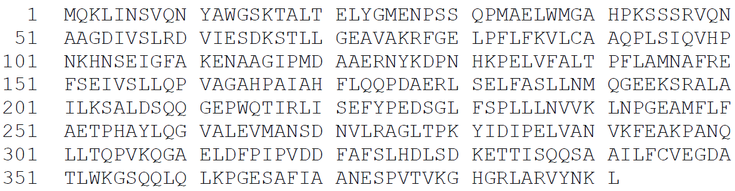
PMI has been assessed by FSANZ previously as a novel protein in four corn lines and one rice line. A translation of the DNA sequence of the pmi gene in DP23211 (Figure 4) yielded a protein whose sequence is identical to that expressed in four of the previously assessed lines. The PMI protein is comprised of 391 amino acids with a calculated molecular weight of ~43 kilodalton (kDa).
Figure 4. Deduced amino acid sequence of the PMI protein

4.1.1.1 Characterisation of PMI expressed in DP23211 tissue
To characterise the DP23211-derived PMI, the applicant extracted the protein from whole DP23211 tissue using a PMI-specific antibody. The purified PMI was then characterised using a number of analyses and the results are summarised below.
Molecular weight. Purified DP23211-derived PMI was analysed via Sodium Dodecyl Sulfate Polyacrylamide Gel Electrophoresis (SDS-PAGE) and visualised using Coomassie staining. A single band was detected at the expected molecular weight of PMI.
Immunoreactivity. Western blot analysis with a PMI-specific antibody showed that the protein being expressed in DP23211 was PMI.
Peptide mapping. Two samples of DP23211-derived PMI were digested with either trypsin or chymotrypsin and analysed via mass spectrometry. The combined sequence coverage was 88% (346/391 amino acids), showing that the protein being expressed in DP23211 was PMI.
N-terminal sequencing. Amino acids 1-11 of DP23211-derived PMI were sequenced and the sequence was as expected. The N-terminal methionine residue was acetylated, which is a common process in eukaryotes (Ree et al., 2018).
Glycosylation analysis. An SDS-PAGE and glycoprotein staining procedure showed the DP23211-derived PMI and a negative control protein were not glycosylated, while the positive control showed a band indicative of glycosylation.
PMI was used as a selectable marker during the transformation procedure, allowing the selection of plant cells with the intended DNA insertion. This demonstrates the function of PMI in DP23211.

4.1.1.2 Expression of PMI protein in DP23211 tissue
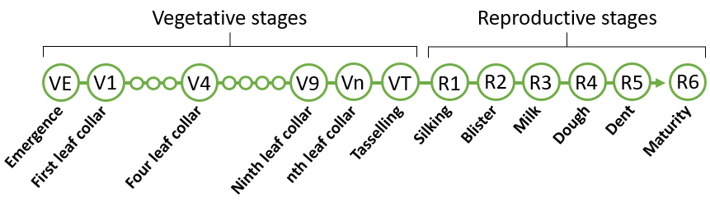
PMI expression levels were quantified using a quantitative Enzyme-Linked ImmunoSorbent Assay (ELISA). Various tissues at different growth stages were examined from DP23211, DP23211 treated with glufosinate and the non-GM near-isoline (PHEJW/PHR03) control. Figure 5 depicts the different growth stages in corn. For each tissue analysed, four samples were processed from each of the six field-trial sites. The study was conducted during the 2018 growing season in corn growing regions in the US and Canada.
Figure 5: Stages of corn growth. Grain is harvested at R6.
Results from the ELISA (Table 5) show that PMI was detected in herbicide-treated DP23211, with the highest expression in pollen in the early reproductive stage (R1), when pollen is produced. By maturity (R6), PMI is detected in the grain. Similar levels of PMI expression were detected in DP23211 not treated with glufosinate. Additionally, there was no detection of PMI in the control, as expected because this line does not contain the pmi gene.
Table 5: Expression of PMI (µg/g DW¹) in various tissues
Tissue | Growth Stage² | Glufosinate-treated DP23211
 |  | Mean | Range | SD³
Root | V6 | 11 | 5.7 - 19 | 4.0
 | V9 | 5.6 | 2.8 - 8.7 | 1.8
 | R1 | 5.0 | 2.6 - 8.4 | 1.7
 | R4 | 4.0 | 1.7 - 6.6 | 1.3
 | R6 | 2.3 | <0.27 - 5.1 | 1.8
Leaf | V9 | 8.8 | 5.6 - 14 | 2.1
 | R1 | 13 | 8.4 - 22 | 3.7
 | R4 | 28 | 19 - 40 | 5.7
 | R6 | 0.50 | <0.54 - 5.8 | 1.1
Pollen | R1 | 33 | 28 - 43 | 4.6
Forage | R4 | 9.3 | 4.8 - 13 | 1.8
Whole Plant | R1 | 9.1 | 7.4 - 12 | 1.3
 | R6 | 3.3 | <1.8 - 8.6 | 2.0
Grain | R6 | 3.9 | 1.6 - 6.0 | 1.1
1. DW - dry weight. 2. Growth Stage abbreviations – see Figure 5. 3. SD – standard deviation;

4.1.1.3 Safety of the introduced PMI
The PMI protein has been previously assessed by FSANZ in corn lines 5307 – Application A1060 (FSANZ 2012), MIR162 – Application A1001 (FSANZ 2008a), 3272 – Application A580 (FSANZ 2008b) and MIR604 – Application A564 (FSANZ 2006), and rice line GR2E – Application A1038 (FSANZ 2017). In all of these applications, studies on potential allergenicity and toxicity were submitted and assessed, the most recent of which was for A1038. These previous assessments did not raise any safety concerns and there have been no credible reports of adverse health effects in humans. Since the amino acid sequence of the protein expressed in DP23211 is identical to the PMI sequence expressed in three of the corn lines and the rice line, no further safety evaluation is required other than the examination of updated bioinformatics searches.
Updated bioinformatic studies for PMI that looked for amino acid sequence similarity to known protein allergens and toxins were provided by the applicant (February 2019). The results do not alter conclusions reached in previous assessments. Similar to all previous alignments, there was one sequence identity match of eight contiguous identical amino acids between PMI and a known allergen, α-parvalbumin from a Rana (frog) species (Hilger et al., 2002). Using serum IgE screening, further investigation demonstrated no cross-reactivity between PMI and the α-parvalbumin protein using serum from the single individual known to have demonstrated IgE-mediated allergy to this specific α-parvalbumin from the Rana species. The results indicated that the allergic patient’s serum IgE does not recognize any portion of PMI as an allergenic epitope.
The applicant also provided an acute oral toxicity study in mice using PMI protein, although this is not a requirement. The results of this study do not alter conclusions reached in previous assessments.

4.1.1.4 Conclusion
The data presented by the applicant confirms DP23211 expresses a protein that is immunoreactive to a PMI antibody, matches the expected size and sequence of PMI. The protein is expressed throughout the plant, including the grain. Updated bioinformatic analyses confirm PMI has no significant similarity with known allergens or toxins.

4.1.2 PAT
PAT is a acetyltransferase enzyme which inhibits phosphinothricin (PPT) (Strauch et al., 1988; Wohlleben et al., 1988). PPT is the active constituent of glufosinate ammonium herbicides and it inhibits the endogenous plant enzyme glutamine synthetase. This enzyme is involved in amino acid biosynthesis in plant cells and its inhibition causes rapid accumulation of ammonia, leading to plant death. In glufosinate-tolerant GM plants, the introduced PAT enzyme chemically inactivates PPT by acetylation of the free ammonia group to produce N-acetyl glufosinate, thus allowing plants to continue amino acid biosynthesis in the presence of the herbicide.
PAT enzyme for glufosinate-tolerance in crops has been used for approximately 25 years (CERA 2011). Since 2002, FSANZ has assessed and approved numerous events with pat encoded glufosinate-tolerance. There have been no credible reports of adverse effects on human health since it was introduced into food.
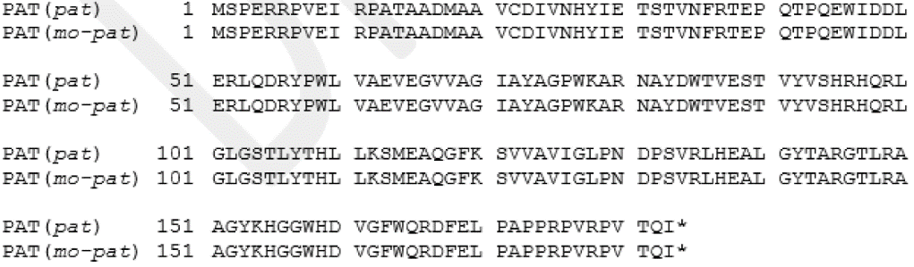
The mo-pat gene in DP23211 has been codon optimised for expression in corn. The deduced amino acid sequence is identical to that produced in the source organism S. viridochromogenes (Figure 6), with the protein being comprised of 183 amino acids with a calculated molecular weight of ~21 kilodalton (kDa).
Figure 6. Deduced amino acid sequence of the PAT protein encoded by pat and mo-pat genes. *Stop codon

4.1.2.1 Characterisation of PAT expressed in DP23211
To characterise DP23211-derived PAT, the applicant extracted the protein from whole DP23211 tissue using a PAT-specific antibody. The purified PAT was then characterised using number of analyses and the results are summarised below.
Molecular weight. Purified DP23211-derived PAT was analysed via SDS-PAGE and visualised using Coomassie staining. A predominant band was detected at the expected molecular weight of PAT.
Immunoreactivity. Western blot analysis with a PAT-specific antibody showed that the protein being expressed in DP23211 was PAT.
Peptide mapping. Two samples of DP23211-derived PAT were digested with either trypsin or chymotrypsin and analysed via mass spectrometry. The combined sequence coverage was 95% (173/183 amino acids), showing that the protein being expressed in DP23211 was PAT.
N-terminal sequencing. Amino acids 2-11 of DP23211-derived PAT were sequenced and the sequence was as expected. The first N-terminal methionine residue was missing, likely due to cleavage which is a common process in many organisms (Wingfield 2017).
Glycosylation analysis. An SDS-PAGE and glycoprotein staining procedure showed the DP23211-derived PAT and a negative control protein were not glycosylated, while the positive control showed a band indicative of glycosylation.
The function of PAT in providing DP23211 with tolerance to glufosinate was demonstrated in the phenotypic stability analysis (see Section 3.4.3.2).

4.1.2.2 Expression of PAT protein in DP23211 tissue
PAT expression was determined using an ELISA on the same processed tissue samples analysed for PMI (Section 4.1.1.2). Results from the ELISA (Table 6) show that PAT was detected in herbicide-treated DP23211, with the highest expression in pollen in the early reproductive stage (R1). By maturity (R6), PAT is detected in the grain and is below the lower limit of quantification in leaf tissue. Similar levels of PAT expression were detected in DP23211 not treated with glufosinate. There was no detection of PAT in the control. This result is as expected because this line does not contain the mo-pat gene.
Table 6: Expression of PAT (µg/g DW¹) in various tissues
Tissue | Growth Stage² | Glufosinate-treated DP23211
 |  | Mean | Range | SD³
Root | V6 | 7.5 | 1.3 - 11 | 2.5
 | V9 | 4.0 | 1.6 - 6.0 | 1.2
 | R1 | 3.7 | 1.9 - 5.1 | 1.0
 | R4 | 1.3 | 0.26 - 2.7 | 0.65
 | R6 | 0.64 | <0.054 - 2.4 | 0.79
Leaf | V9 | 7.5 | 5.0 - 11 | 1.5
 | R1 | 6.6 | 4.9 - 8.4 | 1.0
 | R4 | 3.4 | 2.3 - 5.3 | 0.80
 | R6 | <0.11 | <0.11 | NA
Pollen | R1 | 54 | 35 - 80 | 12
Forage | R4 | 7.9 | 5.2 - 12 | 1.8
Whole Plant | R1 | 9.2 | 5.6 - 12 | 1.8
 | R4 | 1.1 | <0.036 - 6.2 | 1.5
Grain | R6 | 4.3 | 2.0 - 6.6 | 1.4
1. DW - dry weight. 2. Growth Stage abbreviations – see Figure 5. 3. SD – standard deviation; 4. NA – not applicable.

4.1.2.3 Safety of the introduced PAT
The PAT protein encoded by the pat gene has been considered in 17 previous FSANZ safety assessments, eight of which involved corn. These assessments, together with the published literature, firmly establish the safety of PAT and confirm that it does not raise toxicity or food allergenicity concerns in humans (ILSI 2016; Hammond et al., 2011; Delaney et al., 2008; Hérouet et al., 2005).
In previous FSANZ assessments, studies on potential allergenicity and toxicity were submitted and assessed. These previous assessments did not raise any safety concerns and there have been no credible reports of adverse health effects in humans. Since the sequence of the protein expressed in DP23211 is identical to the previous PAT sequences assessed by FSANZ, no further safety evaluation is required other than the examination of updated bioinformatics searches.
The applicant has submitted updated bioinformatic studies for PAT that looked for amino acid sequence similarity to known protein allergens and toxins (January 2019). The results do not alter conclusions reached in previous assessments.
The applicant also provided an acute oral toxicity study in mice using PAT protein, although this is not a requirement. The results of this study do not alter conclusions reached in previous assessments.

4.1.2.4 Conclusion
The data presented by the applicant confirms DP23211 expresses a protein that is immunoreactive to a PAT antibody and matches the expected size and sequence of PAT. The protein is expressed in various plant tissues, including grain. Updated bioinformatic analyses continue to indicate PAT has no significant similarity with known allergens or toxins.

4.1.3 IPD072Aa
The IPD072Aa protein was isolated from P. chlororaphis cultured from a soil sample and identified as having a potent inhibitory effect on the survival of western corn rootworm larvae (WCR; D. virgifera). This effect is restricted to certain species within the Coleoptera order. WCR displays the greatest sensitivity to IPD072Aa consumption, while several lepidopteran and hemipteran species are unaffected by IPD072Aa consumption (Boeckman et al., 2019; Schellenberger et al., 2016).
Similar to crystal (Cry) proteins from B. thuringiensis, the IPD072Aa protein targets and disrupts midgut epithelial cells in insects. However, it appears the mechanism of action of IPD072Aa differs from Cry proteins. Cry proteins function by binding to a highly specific glycoprotein receptor on the surface of midgut epithelial cells, aggregating and forming pores in the cell membrane (Schnepf et al., 1998). The IPD072Aa protein causes midgut epithelial cells to swell and bust, resulting in the loss of gut integrity and larval death within 1 to 2 days. IPD072Aa has the ability to kill WCR larvae that are resistant to specific Cry proteins (Schellenberger et al., 2016) indicating that the action of IPD072Aa in causing midgut epithelium breakdown might involve a non-pore forming mechanism.
Humans may have inadvertently been exposed to the IPD072Aa protein because for approximately twenty years the source organism, P. chlororaphis, has been used as a bio-pesticide in multiple agricultural settings, including the control of fungal diseases in cereal grains (Mark et al., 2006; Johnsson et al., 1998). P. chlororaphis has a history of safe use in agriculture and in food and feed crops (Anderson & Kim, 2020; Arrebola et al., 2019).
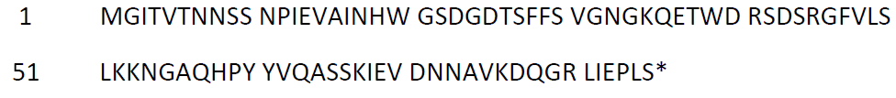
The deduced amino acid sequence from the translation of the P. chlororaphis ipd072Aa gene is shown in Figure 7. The deduced IPD072Aa protein is comprised of 86 amino acids, with a calculated molecular weight of ~10 kilodalton (kDa).
Figure 7. Deduced amino acid sequence of IPD072Aa. * stop codon

4.1.3.1 Characterisation of IPD072Aa in DP23211 and equivalence to a bacterially-produced form
The equivalence of the DP23211- and E. coli-derived IPD072Aa proteins must be established before the safety data generated using E. coli-derived IPD072Aa can be applied to DP23211-derived IPD072Aa.
The plant-derived IPD072Aa was partially purified from DP23211 whole plant tissue by ammonium sulfate precipitation and immuno-affinity chromatography. To generate sufficient amounts of E. coli-purified IPD072Aa protein, E. coli were fermented with a plasmid that expresses the IPD072Aa protein with an N-terminal histidine tag (His-tag). Nickel-nitrilotriacetic acid (Ni-NTA) chromatography was used twice, first to purify the tagged protein and then to remove the His-tag following its cleavage from IPD072Aa by immobilised trypsin. The E. coli-derived IPD072Aa was then purified.
In order to confirm the identity and equivalence of the DP23211- and E. coli-derived IPD072Aa proteins, a series of analytical techniques were employed. The results are summarised below.
Molecular weight. Samples of purified DP23211- and E. coli-derived IPD072Aa proteins were run on SDS-PAGE then visualised with Coomassie staining. While the DP23211-derived protein sample showed less purity than the E. coli-derived IPD072Aa protein sample, this is expected considering the differences in protein source and purification. Nevertheless, a predominant band was detected in all samples at the expected molecular weight.
Immunoreactivity. Western blot analysis with a IPD072Aa-specific antibody showed that the protein being expressed in DP23211 and E. coli was in fact IPD072Aa and they have equivalent immunoreactivity.
Peptide mapping. Two samples of DP23211-derived IPD072Aa protein were digested with either trypsin or chymotrypsin and analysed via mass spectrometry. The combined sequence coverage was 65% (56/86 amino acids). E. coli-derived IPD072Aa was digested with chymotrypsin only and similarly analysed via mass spectrometry. Matched peptides accounted for 100% of the expected IPD072Aa sequence and includes an N-terminal histidine, a remnant amino acid from the His-tag. These results show that the protein being expressed in DP23211 and E. coli were in fact IPD072Aa.
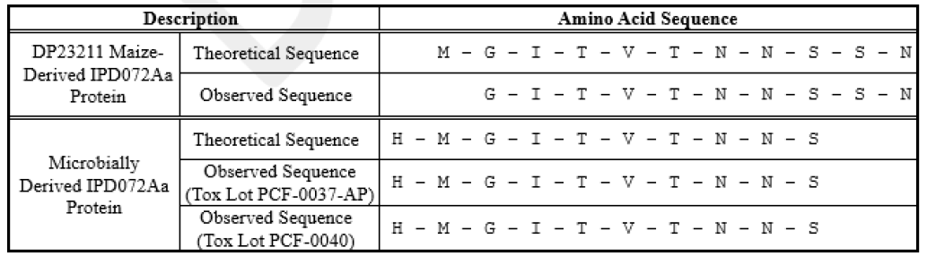
N-terminal sequencing. Amino acids 2-11 of DP23211-derived IPD072Aa were sequenced and the sequence was as expected (Figure 8). The first N-terminal methionine residue was most likely cleaved, which is a common process in many organisms (Wingfield 2017). For the E. coli-derived IPD072Aa protein, amino acids 1-10 amino acids were sequenced and the sequence was as expected (Figure 8). The E. coli-derived IPD072Aa protein contained an N-terminal histamine, which was expected and complementary to the peptide mapping results.
Figure 8. N-terminal amino acid sequences of DP23211- and E. coli-derived IPD072Aa
Glycosylation analysis. An SDS-PAGE and glycoprotein staining procedure showed the IPD072Aa protein from both DP23211 and E. coli was equivalent and that neither is glycosylated. The negative control protein was not glycosylated, while the positive control showed a band indicative of glycosylation.
The biological activity of E. coli-derived IPD072Aa protein was evaluated in a 7-day bioassay using WCR larvae. The test diet contained a targeted concentration of 100 ng IPD072Aa protein / mg diet wet weight and the control diet contained a dosing solution of water. Larvae fed a diet containing E. coli-derived IPD072Aa protein showed a mortality of 97%, compared to 13% in the control diet. This result demonstrates that E. coli-derived IPD072Aa protein is functionally active against WCR.
The data outlined in this section demonstrated that the E. coli-derived DP23211 protein is structurally and biochemically equivalent to DP23211-derived IPD072Aa. The functioning of IPD072Aa was demonstrated in the E. coli-derived IPD072Aa and based on the structural and biochemical equivalence to DP23211-derived IPD072Aa, the two proteins are expected to be functionally equivalent. It can be concluded that E. coli-derived DP23211 protein is a suitable surrogate for use in the safety assessment experiments described in Section 4.1.3.3.

4.1.3.2 Expression of IPD072Aa in DP23211
IPD072Aa expression was determined using an ELISA on the same processed tissue samples analysed for PMI and PAT (Section 4.1.1.2 and 4.1.2.2). Results from the ELISA (Table 7) show that IPD072Aa was detected in herbicide-treated DP23211, with the highest expression in root tissue, which is the target tissue for corn rootworm larvae consumption. IPD072Aa is detected in the grain at a very low level compared to root tissue, and pollen had the lowest level of IPD072Aa expression. Similar levels of IPD072Aa were detected in DP23211 not treated with glufosinate. Additionally, there was no detection of IPD072Aa in the control, as expected because this line does not contain the ipd072Aa gene.
Table 7: Expression of IPD072Aa (µg/g DW¹) in various tissues
Tissue | Growth Stage² | Glufosinate-treated DP23211
 |  | Mean | Range | SD³
Root | V6 | 27 | 6.9 - 57 | 16
 | V9 | 18 | 3.3 - 63 | 21
 | R1 | 23 | 11 - 33 | 7.8
 | R4 | 27 | 4.2 - 54 | 13
 | R6 | 27 | 0.87 - 57 | 18
Leaf | V9 | 13 | 2.4 - 40 | 11
 | R1 | 15 | 4.7 - 32 | 6.9
 | R4 | 9.5 | 6.0 - 17 | 2.9
 | R6 | 1.8 | <0.054 - 20 | 4.3
Pollen | R1 | 0.66 | 0.12 - 1.3 | 0.39
Forage | R4 | 16 | 6.4 - 38 | 8.1
Whole Plant | R1 | 6.3 | 3.6 - 10 | 1.6
 | R6 | 9.8 | 1.1 - 36 | 9.9
Grain | R6 | 1.8 | 0.21 - 5.7 | 1.4
1. DW - dry weight. 2. Growth Stage abbreviations – see Figure 5. 3. SD – standard deviation.

4.1.3.3 Safety of the introduced IPD072Aa
The IPD072Aa has not been previously assessed by FSANZ. Data were provided to assess the potential toxicity and allergenicity of IPD072Aa expressed in DP23211.
Bioinformatic analyses of IPD072Aa
In silico analyses comparing the IPD072Aa amino acid sequence to known allergenic proteins in the COMPARE database (January 2019) were performed by the applicant. The same search criteria as outlined in Section 3.4.5.1 were used. Similar to the ORF analysis, the search did not identify any known allergens with homology to IPD072Aa. No alignments met or exceeded the threshold of ≥ 35% over 80 amino acids and no eight amino acid peptide matches were shared between the IPD072Aa sequence and proteins in the allergen database.
The applicant provided the results of in silico analyses comparing the IPD072Aa amino acid sequence to proteins identified as “toxins” in the same in-house database described in Section 3.4.5.2 (January, 2019). A BLASTP algorithm was used with a BLOSUM62 scoring matrix, the low complexity filtering was turned off and the E-value threshold set to 0.0001. The search did not identify any known toxins with homology to IPD072Aa.
Susceptibility of IPD072Aa to digestion with pepsin and pancreatin
E. coli-derived IPD072Aa (test substance) was incubated with pepsin (10U enzyme/μg protein) at 37°C over a 0-60 min time course, in a simulated gastric fluid (SGF) system at an acidic pH of ~1.2 (Thomas et al., 2004). Controls included the BSA or β-lactoglobulin proteins in SGF incubated for 0 and 60 min, no protein in SGF incubated for 60 min, and IPD072Aa in water or a gastric control solution that did not contain pepsin and was incubated for 60 min. The extent of digestion was visualised using GelCode Blue Stain Reagent on an SDS-PAGE gel, followed by Western blotting.
The results from the pepsin digestion showed that by 0.5 min, there was no intact IPD072Aa remaining in the reaction mix. The BSA control was digested within 1 min in SGF and the β-lactoglobulin control remained in the reaction mix after 60 min. IPD072Aa remained intact after 60 min in water and in the gastric solution without pepsin. These results indicated the protein was fully digested by pepsin.
E. coli-derived IPD072Aa protein was also incubated with pancreatin (40 μg enzyme/μg protein) at 37°C over a 0-60 min time course, in a simulated intestinal fluid (SIF) system at a neutral pH of ~7.5. Pancreatin is a mixture of proteolytic enzymes. Controls included the BSA or β-lactoglobulin proteins in SIF incubated for 0 and 60 min, no protein in SIF incubated for 60 min, and IPD072Aa in water or an intestinal control solution that did not contain pancreatin and was incubated for 60 min. The extent of digestion was visualised using GelCode Blue Stain Reagent on an SDS-PAGE gel, followed by Western blotting.
The results from the pancreatin digestion showed that by 20 min, there was no intact IPD072Aa remaining in the reaction mix. Some of the BSA control remained undigested after 60 min in SIF and the β-lactoglobulin control was digested within 1 min in SIF. IPD072Aa remained intact after 60 min in water and in the intestinal solution without pancreatin. These results indicated the protein was fully digested by pancreatin.
Bioactivity of IPD072Aa after exposure to heat
Heat-treated IPD072Aa was incorporated into an artificial diet and tested in a functional activity assay that measured the mortality of WCR larvae. The diets included E. coli-derived IPD072Aa (test diet) that was subjected to 30 min incubations at 25°C, 50°C, 60°C, 95°C or autoclaved at 121°C (20 psi). The test diets contained a targeted concentration of 50 ng IPD072Aa protein per mg diet wet weight. Controls included an unheated IPD072Aa and a diet of ultrapure water. Each diet was provided to 30 individual WCR for a total of 7 days and Western blot analysis visually confirmed the dose and homogeneity of the IDP072Aa protein during the assay.
At all incubation temperatures (25-95°C) the ability of IPD072Aa to cause WCR mortality remained similar to the unheated IPD072Aa (Table 8). Although there was a progressive decrease in mortality rate between 25°C and 95°C, these values were not significantly different to the unheated test diet. A significant reduction in mortality rate, compared to the unheated test diet, was observed with the diet that contained the 121°C autoclave treatment of IPD072Aa. Mortality rate was similar to the diet of ultrapure water, indicating that at 121°C and 20 psi the IPD072Aa protein completely loses its functional activity.
Table 8: Bioactivity of heat-treated IPD072Aa in a diet fed to WCR
Treatment description | Incubation condition | Number of observations¹ | Total number of dead organisms | Mortality | Significance²
Water diet | - | 29 | 8 | 27.6 | -
Test diet | Unheated | 22 | 20 | 90.9 | -
 | 25°C | 29 | 26 | 89.7 | NS
 | 50°C | 26 | 23 | 88.5 | NS
 | 60°C | 28 | 24 | 85.7 | NS
 | 95°C | 24 | 20 | 83.3 | NS
 | 121°C (autoclaved) | 29 | 4 | 13.8 | P < 0.0001
A treatment with a P value of < 0.05 was considered significant. 1. The bioassay started with 30 organisms per treatment, but organisms were omitted from the final tally if they were missing or wells contained more than one organism. 2. Significance in comparison to the unheated test diet. NS – not significant.

Although IPD072Aa retains biological activity following heat treatment up to 95°C, this is not directly predictive of allergenicity or toxicity potential. The bioinformatic analysis demonstrated the protein does not have any amino acid similarity to know allergens or protein toxins and the digestibility studies suggest that the IPD072Aa would be rapidly degraded following ingestion.
Acute oral toxicity study
A 14-day acute oral toxicity study in mice using E.coli-derived IPD072Aa was submitted by the applicant. A single 2000 mg/kg bodyweight (BW) dose of IPD072Aa was administered to six male and six female Crl:CD1(ICR) mice. In addition, two groups of six male and six female mice were administered with either 2000 mg/kg BSA control or the vehicle control (deionised water). Both protein preparations were reconstituted in deionised water and all formulations were administered by oral gavage.
Body weights were measured on test days 1 (prefast and shortly before dose administration), 2, 5, 8 and 15. The evaluation of clinical signs was performed before and after dosing on test day 1 and daily thereafter. All mice were killed on day 15 and gross pathological examination was performed. No mortalities, clinical abnormalities, losses of body weight or gross lesions were observed during the course of the study.
In summary, no treatment-related adverse effects were observed at the 2000 mg/kg BW oral dose of IPD072Aa.

4.1.3.4 Conclusion
A range of characterisation studies were performed on plant-derived IPD072Aa confirming its identity, structure and biochemistry as well as equivalence of the corresponding protein derived in a bacterial expression system. The bacterially-expressed IPD072Aa was also shown to be functional. Expression of IPD072Aa in DP23211 was highest in root tissue and lowest in pollen. While the IPD072Aa protein was stable at temperatures of up to 95°C, the protein was susceptible to pepsin and pancreatin digestion and bioinformatic analyses showed IPD072Aa had no homology to known toxins and allergens. Additionally, an acute oral toxicity study in mice did not result in any treatment-related adverse effects. Taken together this indicates that the IPD072Aa protein is unlikely to be toxic or allergenic to humans.

4.2 Newly expressed dsRNA

4.2.1 DvSSJ1 dsRNA
A double-stranded RNA construct was introduced into DP23211. The dsRNA sequence silences the dvssj1 gene in WCR, i.e. the target of the dsRNA is an external pest and not an endogenous corn gene. When WCR ingests DP23211, midgut epithelial cells take up DvSSJ1 dsRNA which are then processed by the RNAi post-transcriptional regulatory pathway in the cell into small interfering RNA (siRNA) and forms an RNA-induced silencing complex. This complex binds to the specific target gene mRNA resulting in cleavage and degradation of the mRNA. This process is known as RNA interference (RNAi) and it exists innately in most eukaryotic organisms (Kim and Rossi, 2008). While dsRNA processing into siRNA will also occur in the plant, intact dsRNA would be present and there is evidence to suggest that the DvSSJ1 dsRNA in planta is the functional RNA form in the control of WCR (Hu et al., 2020).
DvSSJ1 RNAi silences dvssj1 mRNA in WCR midgut epithelial cells resulting in decreased translation of the DvSSJ1 protein. This protein is part of the smooth septate junction (SSJ) protein complex, a type of occluding junction found in invertebrate epithelial cells that is involved in physically connecting adjacent epithelial cells to create the intestinal barrier and are important in regulating invertebrate gut homeostasis (Izumi et al., 2019). The WCR dvssj1 gene is an ortholog of the Drosophila snakeskin gene, the protein of which is a critical component of the SSJ protein complex (Hu et al., 2016). Reduction of DVSSJ1 protein in WCR disrupts the SSJ protein complex and leads to loss of barrier integrity, larval growth inhibition and mortality (Hu et al., 2019).

4.2.1.1 Expression of DvSSJ1 dsRNA in DP23211
The applicant provided a study analysing the concentration of DvSSJ1 dsRNA in various DP23211 tissues. The field trial design was identical to that of the expression analysis of PMI, PAT and IPD072Aa proteins (see Section 4.1.1.2 for description). DvSSJ1 dsRNA concentration was determined using a multiplexed gene expression quantification assay (QuantiGene Plex Assay). The results of the glufosinate treated DP23211 showed that DvSSJ1 dsRNA had the highest expression level in leaf tissue and lowest in pollen closely followed by grain (Table 9). In root tissue, the target tissue for corn rootworm larvae consumption, the levels on DvSSJ1 dsRNA was fairly comparable to leaf and expression levels were higher in earlier growth stages. There was very similar levels of DvSSJ1 dsRNA expression in DP23211 not treated with glufosinate. Additionally, there was no detection of DvSSJ1 dsRNA in the non-GM near-isoline control, as expected because this line does not contain DvSSJ1 dsRNA.
Table 9: Concentration of DvSSJ1 dsRNA (µg/g DW¹) in various tissues
Tissue | Growth Stage² | Glufosinate-treated DP23211 (x10⁻²)
 |  | Mean | Range | SD³
Root | V6 | 5.58 | 2.38 – 10.4 | 2.25
 | V9 | 3.37 | 0.853 – 6.99 | 1.48
 | R1 | 2.87 | 1.52 – 4.61 | 0.812
 | R4 | 2.05 | 0.818 – 3.68 | 0.762
 | R6 | 0.933 | 0.032 – 2.41 | 0.792
Leaf | V9 | 6.39 | 3.69 – 20.6 | 3.34
 | R1 | 5.68 | 2.67 – 10.8 | 2.14
 | R4 | 7.08 | 4.63 – 8.81 | 1.21
 | R6 | 2.93 | 0.106 – 20.8 | 5.86
Pollen | R1 | 0.104 | 0.0666 – 0.194 | 0.0321
Forage | R4 | 2.38 | 1.23 – 7.43 | 1.48
Whole Plant | R1 | 2.44 | 2.01 – 3.68 | 0.370
 | R6 | 0.772 | 0.0527 – 1.79 | 0.482
Grain | R6 | 0.314 | 0.0736 – 1.05 | 0.208
1. DW - dry weight. 2. Growth Stage abbreviations – see Figure 5. 3. SD – standard deviation.

4.2.1.2 Specificity of DvSSJ1 dsRNA
To determine the specificity of the dsRNA, the applicant provided an in silico analysis comparing the 210 bp DvSSJ1 dsRNA sequence to ssj1 homologs from twenty invertebrate species in four orders (Coleoptera, Hymenoptera, Hemiptera and Lepidoptera). The results show that the DvSSJ1 dsRNA sequence is highly specific to corn rootworms in the Diabrotica genus, Chrysomelidae family and Coleoptera order.

4.2.1.3 History of safe use
In a review by FSANZ (2013), it was concluded the weight of evidence in the published literature on gene silencing does not support the view that dsRNA and RNAi mediators, ingested as part of the normal human diet, have any impact on human gene expression or are likely to have adverse consequences for humans. Nucleic acids, including dsRNAs and siRNAs, are already abundantly present in the human diet from both plant and animal sources (Carthew and Sontheimer 2009; Ivashuta et al. 2009). Upon ingestion, enzymes and pH changes in saliva, stomach and intestines degrade nucleic acids into simple components (Hickerson et al. 2008; Martinez et al. 2015; Title et al. 2015), which can then be absorbed or excreted. Even if intact or partially degraded nucleic acid molecules arrive in the intestinal region, the large size, hydrophobicity and charged nature of the molecules will limit absorption across the cell barrier lining the intestinal tract. This has been highlighted by the ineffectiveness of gene therapy strategies using naked DNA. Furthermore, there is no scientific basis for suggesting that, when present as a result of the genetic modification of a plant, dsRNA and RNAi mediators possess different properties or pose a greater risk than those already naturally abundant in foods from conventional non-GM plants, animals and microorganisms such as yeasts.

4.2.1.3 Conclusion
The available data do not indicate the DvSSJ1 dsRNA possess different characteristics, or are likely to pose a greater risk, than other RNAi mediators naturally present in corn. Since the target of the DvSSJ1 dsRNAs is present in WCR, no compositional changes to the food derived from DP23211 is expected to occur from the introduction of this dsRNA. DvSSJ1 dsRNA is specific to corn rootworms within the Diabrotica genus. A history of safe human consumption of RNAi mediators exists, including those with homology to human genes. The evidence published to date also does not indicate that dietary uptake of such RNA from plant food is a widespread phenomenon in vertebrates (including humans) or, if it occurs, that sufficient quantities are taken up to exert a biologically relevant effect (FSANZ, 2013).

4.3 Novel herbicide metabolites in GM herbicide-tolerant plants
FSANZ has assessed the novel herbicide metabolites for glufosinate in GM corn in multiple previous applications. These previous assessments indicate the spraying of DP23211 with glufosinate ammonium results in the same metabolites that are produced in non-GM corn sprayed with the same herbicide. It is expected that no new glufosinate metabolites would be generated in corn event DP23211, therefore this does not require further investigation.

5 Compositional analysis
The main purpose of compositional analyses is to determine if, as a result of the genetic modification, an unexpected change has occurred to the food. These changes could take the form of alterations in the composition of the plant and its tissues and thus its nutritional adequacy. Compositional analyses can also be important for evaluating the intended effect where there has been a deliberate change to the composition of the food.
The classic approach to the compositional analyses of GM food is a targeted one. Rather than analysing every possible constituent, which would be impractical, the aim is to analyse only those constituents most relevant to the safety of the food or that may have an impact on the whole diet. Important analytes therefore include the key nutrients, toxicants and anti-nutrients for the food in question. The key nutrients and anti-nutrients are those components in a particular food that may have a substantial impact in the overall diet. They may be major constituents (fats, proteins, carbohydrates or enzyme inhibitors such as anti-nutrients) or minor constituents (minerals, vitamins). Key toxicants are those toxicologically significant compounds known to be inherently present in an organism, such as compounds whose toxic potency and level may be significant to health.

5.1 Key Components
The key components to be analysed for the comparison of transgenic and conventional corn are outlined in the OECD Consensus Document on Compositional Considerations for New Varieties of Maize (OECD 2002), and include: proximates and fibre, amino acids, fatty acids and the anti-nutrients phytic acid, raffinose, furfual and the phenolic acids ferulic acid and p-coumaric acid.

5.2 Study design
Eight field trials were conducted for DP23211 in the US and Canada in the 2018 growing season. The sites were selected to match the typical geographical and field management styles of the commercial corn growing regions. The materials tested in the field trials included DP23211, the non-GM near-isoline (PHEJW/PHR03) control and a total of 14 reference varieties. Four reference varieties were grown at each site and were selected from P0604, 2R602, 35A52, P0760, BK5883, XL5939, P0928, P0993, XL5828, BK6076, XL6158, P1105, P1151 and P1197. The field trials were established in a randomised complete block design, with four replicates of each plot.
Corn grains were harvested from all plots at maturity, with reference and control grain collected prior to DP23211 to minimise the potential for contamination. After harvest, samples were despatched to an analytical laboratory under full identity labelling. The analyses were performed at EPL Bio Analytical Services. The compositional analyses were based on internationally recognised procedures including official methods specified by the Association of Official Analytical Chemists (AOAC), the Analytical Oil Chemists' Society (AOCS), the American Association of Cereal Chemists (AACC) and published articles or technical notes from industrial-based sources.
69 different analytes were measured and evaluated (listed in Table 10). Statistical analyses were performed using SAS 9.4 (SAS Institute, Cary, North Carolina). For each analyte, ‘descriptive statistics’ (mean, range and 95% confidence interval) were generated. A linear mixed model analysis of variance was then applied for combined data, and locations, covering the eight replicated field trial sites. The mixed model analysis was also applied to the data from each site separately. In assessing the significance of any difference between DP23211 and the control, a P-value of 0.05 was used. Where statistically significant differences were observed in the combined data from all sites (presented in Tables 12-17), analysis of the data from each site was used to determine if the differences were common to the majority of sites. A further adjusted P-value was determined using the false discovery rate (FDR) method, as a consideration of the chance of false positives being observed with the testing due to the multiple analytes being analysed.
In order to complete the statistical analysis for any component in this study, a measured value from an analyte below the lower limit of quantification (LLOQ), was given an arbitrary value of half the LLOQ. Any analyte with all observations below the LLOQ for that assay, were excluded from the overall summary analysis. Values for all components were expressed on a percent dry weight (% DW) basis with the exception of vitamins, expressed as milligrams per kilogram of solid (dry weight), and fatty acids, expressed as percent of total fatty acids.
Any statistically significant differences between DP23211 and the control were compared to an in-house database containing compositional analyses from 144 non-GM commercial lines cultivated across 148 unique environments in North and South America, from 2003-2017. The natural variation of analytes from publically available data was also considered (Watson 1982; OECD 2002; Codex 2013; Lundry et al, 2013; Cong et al, 2015; ILSI 2019). Additionally, compositional data from the non-GM reference varieties grown concurrently in the same trial as DP23211 and the control, were combined across all sites and used to calculate an in-study reference data range for each analyte, to define the variability in corn varieties grown under the same agronomical conditions. These data ranges assist with determining whether any statistically significant differences were likely to be biologically meaningful.

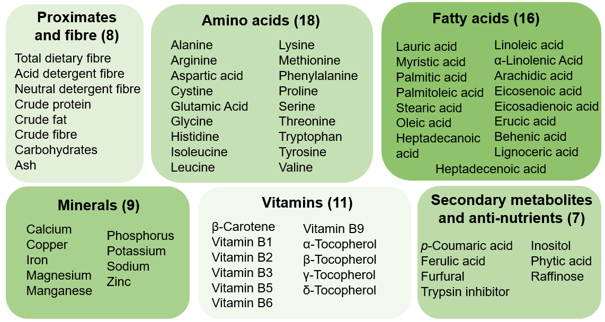
Table 10: Analytes measured in the grain samples

5.3 Analyses of key components in grain

5.3.1 Proximates and fibre
There were no statistically significant differences found in the level of the proximates and fibre in DP23211 compared to the control (Table 11). All means were also within the reference range.
Table 11: Comparison of proximates and fibre (% DW)
Analyte | Control | Herbicide-treated DP23211 | Non-GM reference varieties | Commercial lines | Publically available data
 | Mean (range) | Mean  (range) | Range | Range | Range
Total dietary fibre | 9.71  (8.19-11.7) | 9.92  (7.61-13.3) | 4.44-13.4 | 3.15 - 21.8 | 5.78 - 35.31
Crude protein | 10.6  (8.44-12.0) | 10.6  (6.98-11.6) | 6.95 - 11.3 | 6.66 - 13.3 | 5.72 - 17.26
Crude fat | 4.25  (3.63-4.87) | 4.28  (3.68-4.75) | 3.66 - 5.41 | 2.34 - 5.90 | 1.363 - 7.830
Crude fibre | 2.43  (1.97-2.71) | 2.43  (2.02-3.13) | 2.02 - 3.14 | 1.57 - 3.61 | 0.49 - 5.5
Acid detergent fibre | 4.22  (3.22-4.84) | 4.09  (3.32-5.26) | 3.20 - 5.69 | 2.64 - 6.24 | 1.41 - 11.34
Neutral detergent fibre | 10.5  (8.12-12.8) | 10.7  (8.45-12.9) | 8.15 - 13.3 | 7.49 - 18.6 | 4.28 - 24.3
Ash | 1.37  (1.24-1.49) | 1.39  (1.23-1.51) | 1.04 - 1.49 | 1.01 - 1.87 | 0.616 - 6.282
Carbohydrates | 83.7  (82.4-85.9) | 83.7  (82.7-87.3) | 82.9 - 87.6 | 80.5 - 88.5 | 77.4 - 89.7

5.3.3 Amino acids
Using the raw P-value, a statistically significant difference was observed in DP23211 compared to the control for tyrosine (Table 12). However, an FDR adjusted P-value indicates that the difference is not significant. Additionally, the observed mean value of tyrosine in DP23211 falls well within the variance seen in the reference lines grown under the same conditions, the commercial lines and publically available data. This difference is considered minor and is not biologically significant.
No other statistically significant differences in amino acids were observed between DP23211 and the control (Table 12). Means were also within the reference range.
Table 12: Comparison of amino acids (% DW)
Analyte | Control | Herbicide-treated DP23211 | Non-GM reference varieties | Commercial lines | Publically available data
 | Mean  (range) | Mean  (range) | Range | Range | Range
Alanine | 0.812  (0.601 - 0.929) | 0.809  (0.482 - 0.940) | 0.505 - 0.889 | 0.457 - 1.07 | 0.40 - 1.48
Arginine | 0.455  (0.388 - 0.500) | 0.442  (0.338 - 0.518) | 0.356 - 0.486 | 0.302 - 0.598 | 0.12 - 0.71
Aspartic Acid | 0.683  (0.538 - 0.756) | 0.686  (0.449 - 0.779) | 0.475 - 0.730 | 0.414 - 0.901 | 0.30 - 1.21
Cystine | 0.220  (0.160 - 0.288) | 0.218  (0.145 - 0.294) | 0.114 - 0.276 | 0.132 - 0.295 | 0.12 - 0.51
Glutamic Acid | 2.12  (1.55 - 2.45) | 2.11  (1.20 - 2.45) | 1.25 - 2.32 | 1.11 - 2.76 | 0.83 - 3.54
Glycine | 0.391  (0.345 - 0.423) | 0.381  (0.304 - 0.432) | 0.304 - 0.423 | 0.285 - 0.485 | 0.184 - 0.685
Histidine | 0.317  (0.270 - 0.360) | 0.307  (0.215 - 0.366) | 0.202 - 0.325 | 0.190 - 0.380 | 0.14 - 0.46
Isoleucine | 0.376  (0.287 - 0.428) | 0.375  (0.235 - 0.435) | 0.235 - 0.404 | 0.213 - 0.498 | 0.18 - 0.69
Leucine | 1.41  (1.03 - 1.67) | 1.39  (0.764 - 1.66) | 0.759 - 1.53 | 0.694 - 1.85 | 0.60 - 2.49
Lysine | 0.309  (0.258 - 0.352) | 0.301  (0.224 - 0.338) | 0.254 - 0.346 | 0.178 - 0.396 | 0.129 - 0.668
Methionine | 0.206  (0.163 - 0.253) | 0.204  (0.134 - 0.256) | 0.0934 - 0.268 | 0.120 - 0.328 | 0.10 - 0.47
Phenylalanine | 0.572  (0.449 - 0.674) | 0.546  (0.317 - 0.696) | 0.318 - 0.590 | 0.303 - 0.736 | 0.24 - 0.93
Proline | 1.04  (0.804 - 1.19) | 1.03  (0.632 - 1.20) | 0.641 - 1.07 | 0.557 - 1.26 | 0.46 - 1.75
Serine | 0.540  (0.434 - 0.614) | 0.534  (0.352 - 0.625) | 0.348 - 0.572 | 0.307 - 0.685 | 0.15 - 0.91
Threonine | 0.393  (0.331 - 0.434) | 0.390  (0.279 - 0.441) | 0.270 - 0.410 | 0.245 - 0.491 | 0.17 - 0.67
Tryptophan | 0.0650  (0.0490 - 0.0791) | 0.0667  (0.0558 - 0.0757) | 0.0512 - 0.0843 | 0.0376 - 0.0991 | 0.027 - 0.215
Tyrosine | 0.312  (0.252 - 0.396) | 0.294  (0.179 - 0.378) | 0.192 - 0.359 | 0.170 - 0.557 | 0.10 - 0.73
Valine | 0.482  (0.386 - 0.536) | 0.481  (0.324 - 0.540) | 0.329 - 0.513 | 0.307 - 0.629 | 0.21 - 0.86
Cells highlighted in blue show statistically significant differences using the raw P-value

5.3.3 Fatty acids
Using the raw P-value, a statistically significant difference was observed in DP23211 compared to the control for stearic acid (C18:0), arachidic acid (C20:0) and eicosenoic acid (C20:1) (Table 13). However, an FDR adjusted P-value indicates that the differences are not significant. Furthermore, the observed means for these fatty acids in DP23211 fall well within the variance seen in the reference lines grown under the same conditions, the commercial lines and publically available data. These differences are considered minor and are not biologically significant.
The following fatty acids were excluded from the Table 13 summary due to levels below the LLOQ: erucic acid (C22:1), heptadecenoic acid (C17:1), myristic acid (C14:0). All other fatty acids did not show statistically significant differences between DP23211 and the control (Table 13). Means were also within the reference range.
Table 13: Comparison of fatty acids (% total fatty acids)
Analyte | Control | Herbicide-treated DP23211 | Non-GM reference varieties | Commercial lines | Publically available data
 | Mean  (range) | Mean  (range) | Range | Range | Range
Lauric acid  (C12:0) | 0.101  (0.0439 - 0.300) | 0.102  (0.0423 - 0.302) | 0.0360 - 0.271 | 0 - 0.209² | ND - 0.698
Palmitic acid  (C16:0) | 13.5  (13.1 - 13.9) | 13.5  (13.2 - 13.9) | 11.1 - 18.0 | 9.33 - 24.7 | 6.81 - 39.0
Palmitoleic acid  (C16:1) | 0.118  (0.0543 - 0.127) | 0.116  (0.0509 - 0.126) | 0.0562 - 0.195 | 0 - 0.445 | ND - 0.67
Heptadecanoic acid  (C17:0) | 0.0734  (0.0454 - 0.105) | 0.0751  (0.0472 - 0.107) | 0.0382 - 0.141 | 0 - 0.236 | ND - 0.203
Stearic acid  (C18:0) | 1.73  (1.58 - 1.94) | 1.78  (1.61 - 1.95) | 1.60 - 2.33 | 1.31 - 3.83 | ND - 4.9
Oleic acid  (C18:1) | 21.5  (20.7 - 22.3) | 21.4  (20.5 - 22.5) | 20.0 - 32.8 | 17.3 - 38.6 | 16.38 - 42.81
Linoleic acid  (C18:2) | 60.1  (58.6 - 60.8) | 60.0  (58.9 - 61.1) | 49.8 - 62.6 | 30.7 - 65.5 | 13.1 - 67.68
α-Linolenic acid  (C18:3) | 1.70  (1.54 - 1.84) | 1.71  (1.54 - 1.87) | 1.35 - 2.02 | 0 - 1.90 | ND - 2.33
Arachidic acid  (C20:0) | 0.361  (0.332 - 0.399) | 0.370  (0.331 - 0.395) | 0.328 - 0.539 | 0.295 - 0.872 | 0.267 - 1.2
Eicosenoic acid  (C20:1) | 0.306  (0.266 - 0.334) | 0.315  (0.283 - 0.333) | 0.233 - 0.425 | 0 - 0.614 | ND - 1.952
Eicosadienoic acid  (C20:2) | <LLOQ¹  (<LLOQ¹) | 0.0502  (0.0397 - 0.0887) | 0.0339 - 0.185 | 0 - 0.825² | ND - 2.551
Behenic acid  (C22:0) | 0.191  (0.0951 - 0.227) | 0.188  (0.0945 - 0.241) | 0.100 - 0.298 | 0 - 0.423 | ND - 0.5
Lignoceric acid  (C24:0) | 0.278  (0.244 - 0.311) | 0.279  (0.254 - 0.306) | 0.252 - 0.501 | 0 - 0.639 | ND - 0.91
Cells highlighted in blue show statistically significant differences using the raw P-value. 1. All fatty acid sample values were below the assay LLOQ. 2. Historical reference data range provided. ND – not detectable.

5.3.4 Minerals
Using the raw P-value, a statistically significant difference was observed in DP23211 compared to the control for magnesium and phosphorus (Table 14). An FDR adjusted P-value indicates that there was a statistically significant difference for phosphorus but not for magnesium. However, the observed means for both phosphorus and magnesium fall within the variance seen in the reference lines grown under the same conditions, the commercial lines and publically available data. Therefore, these differences are considered minor and are not biologically significant.
All other minerals did not show statistically significant differences between DP23211 and the control (Table 14). Means were also within the reference range.
Table 14: Comparison of minerals (% DW)
Analyte | Control | Herbicide-treated DP23211 | Non-GM reference varieties | Commercial lines | Publically available data
 | Mean  (range) | Mean  (range) | Range | Range | Range
Calcium | 0.00361  (0.00245 - 0.00538) | 0.00349  (0.00225 - 0.00508) | 0.00215 -  0.00650 | 0.00167 -  0.00872 | ND - 0.101
Copper | 0.0000904  (<0.0000625¹ - 0.000134) | 0.0000913  (<0.0000625¹ - 0.000155) | <0.0000625¹ - 0.000194 | <0.0000625¹ -  0.000411 | ND - 0.0021
Iron | 0.00176  (0.00139 - 0.00222) | 0.00170  (0.00110 - 0.00220) | 0.000955 -  0.00245 | 0.00123 -  0.00308 | 0.0000712 -  0.0191
Magnesium | 0.132  (0.117 - 0.142) | 0.127  (0.108 - 0.144) | 0.0858 -0.133 | 0.0809 - 0.159 | 0.0035 - 1.000
Manganese | 0.000747  (0.000466 - 0.00101) | 0.000732  (0.000425 - 0.00105) | 0.000359 -  0.000870 | 0.000327 -  0.00123 | 0.0000312 -  0.0054
Phosphorus | 0.359  (0.331 - 0.403) | 0.347  (0.320 - 0.376) | 0.264 - 0.373 | 0.207 - 0.415 | 0.010 - 0.750
Potassium | 0.354  (0.311 - 0.441) | 0.353  (0.310 - 0.424) | 0.306 - 0.486 | 0.255 - 0.534 | 0.020 - 0.720
Sodium | 0.000491  (<0.0000625¹ - 0.00596) | 0.000468  (<0.0000625¹ - 0.00430) | <0.0000625¹ - 0.00953 | <LLOQ¹ - 0.0151 | ND - 0.150
Zinc | 0.00208  (0.00152 - 0.00264) | 0.00205  (0.00150 - 0.00274) | 0.00132 - 0.00312 | 0.00140 - 0.00347 | 0.0000283 -  0.0043
Cells highlighted in blue show statistically significant differences using the raw P-value. 1. One or more samples were below the assay LLOQ. ND – not detectable.

5.3.5 Vitamins
A statistically significant difference was observed in DP23211 compared to the control for Vitamin B6 (Table 15). This was using the raw P-value and an FDR adjusted P-value. However, the observed mean for Vitamin B6 falls within the variance seen in the reference lines grown under the same conditions, the commercial lines and publically available data. Therefore, this difference is considered minor and is not biologically significant.
The following vitamins were excluded from the Table 15 summary due to levels below the LLOQ: Vitamin B2, β-Tocopherol. All other vitamins did not show statistically significant differences between DP23211 and the control (Table 15). Means were also within the reference range.
Table 15: Comparison of vitamins (mg/kg DW)
Analyte | Control | Herbicide-treated DP23211 | Non-GM reference varieties | Commercial lines | Publically available data
 | Mean  (range) | Mean  (range) | Range | Range | Range
β-Carotene | 0.283  (0.111 - 0.475) | 0.303  (0.158 - 0.867) | 0.0996 - 1.71 | 0.0330 - 4.24 | 0.3 - 5.4
Vitamin B1 | 2.43  (1.85 - 2.80) | 2.34  (1.88 - 2.73) | 1.58 - 2.91 | 1.74 - 5.38 | ND - 40.00
Vitamin B3 | 13.0  (10.9 - 17.9) | 13.2  (10.9 - 15.5) | 9.29 - 18.0 | 7.85 - 32.5 | ND - 70
Vitamin B5 | 5.46  (3.46 - 6.57) | 5.51  (4.73 - 6.38) | 4.56 - 6.95 | 2.42 - 7.53 | 3.01 - 14
Vitamin B6 | 2.99  (2.00 - 4.65) | 2.54  (1.60 - 4.39) | 1.62 - 5.26 | 1.61 - 8.88 | ND - 12.14
Vitamin B9 | 1.17  (0.400 - 2.20) | 1.28  (0.596 - 3.07) | 0.280 - 3.63 | 0.323 - 2.44 | ND - 3.50
α-Tocopherol | 3.37  (<0.500¹ - 7.22) | 3.09  (<0.500¹ - 6.58) | <0.500¹ - 19.3 | 0 - 23.5 | ND - 68.67
γ-Tocopherol | 10.8  (<1.00¹ - 17.8) | 11.0  (<1.00¹ - 19.5) | 2.19 - 31.2 | 0 - 44.8 | ND - 58.61
δ-Tocopherol | <0.500¹  (<0.500¹) | 0.264  (<0.500¹ - 0.700) | <0.500¹ - 1.68 | <0.500¹ - 2.61² | ND - 14.61
Cells highlighted in blue show statistically significant differences using the raw P-value. Total tocopherols, calculated as the sum of the α-, β-, γ-, and δ-tocopherol values, did not show a statistically significant difference between DP23211 and the control. 1. One or more samples were below the assay LLOQ. 2. Historical reference data range provided. ND – not detectable.

5.3.6 Anti-nutrients and Secondary Metabolites
The following secondary metabolite was excluded from the Table 16 summary as it was below the LLOQ: furfural. All other anti-nutrients and secondary metabolites did not show statistically significant differences between DP23211 and the control (Table 16). Means were also within the reference range.
Table 16: Comparison of anti-nutrients and secondary metabolites
Analyte | Control | Herbicide-treated DP23211 | Non-GM reference varieties | Commercial lines | Publically available data
 | Mean  (range) | Mean  (range) | Range | Range | Range
ρ-Coumaric acid  (% DW) | 0.0218  (0.0161 - 0.0298) | 0.0210  (0.0161 - 0.0258) | 0.0132 - 0.0403 | 0.00742 - 0.0492 | ND - 0.08
Ferulic acid  (% DW) | 0.233  (0.185 - 0.284) | 0.240  (0.182 - 0.297) | 0.164 - 0.298 | 0.123 - 0.349 | 0.02 - 0.44
Inositol  (% DW) | 0.0257  (0.0180 - 0.0433) | 0.0255  (0.0193 - 0.0378) | 0.0157 - 0.0450 | 0.00966 - 0.0548 | 0.00613 - 0.257
Phytic acid  (% DW) | 1.08  (0.891 - 1.34) | 1.02  (0.715 - 1.23) | 0.696 - 1.21 | 0.493 - 1.33 | ND - 1.940
Raffinose  (% DW) | 0.135  (<0.0800¹ - 0.264) | 0.133  (<0.0800¹ - 0.250) | <0.0800¹ - 0.339 | 0 - 0.396 | ND - 0.466
Trypsin Inhibitor  (Trypsin Inhibitor Units/mg DW) | 2.50  (2.16 - 3.23) | 2.52  (1.85 - 3.34) | 1.64 - 3.21 | 1.03 - 9.18 | ND - 8.42
1. One or more samples were below the assay LLOQ. ND – not detectable.

5.4 Conclusion
Of the 69 analytes measured and evaluated in grain, mean values were provided for 63 analytes. A summary of the seven analytes that showed a statistically significant difference between corn line DP23211 and the control is provided in Table 17.
For the majority of analytes presented in Table 17, the differences in magnitude between DP23211 and control were within 10%, with the exception of vitamin B6, where there was an approximate change of minus (-) 15%. The differences reported here are consistent with the normal biological variability that exists in corn.
Overall, the compositional data are consistent with the conclusion that there are no biologically significant differences in the levels of key constituents in DP23211 when compared with conventional non-GM corn cultivars already available in agricultural markets. Grain from DP23211 can therefore be regarded as equivalent in composition to grain from conventional non-GM corn.
Table 17: Summary of statistically significant (raw P value) compositional differences between control and DP23211
Analyte | Control Mean (range) | DP23211 Mean (range) | Are values within the reference ranges?
 |  |  | Yes / No
Tyrosine | 0.312  (0.252-0.396) | 0.294  (0.179-0.378) | Yes
Stearic acid (C18:0), | 1.73  (1.58-1.94) | 1.78  (1.61-1.95) | Yes
Arachidic acid (C20:0) | 0.361  (0.332-0.399) | 0.370  (0.331-0.395) | Yes
Eicosenoic acid (C20:1) | 0.306  (0.226-0.334) | 0.315  (0.283-0.333) | Yes
Magnesium | 0.132  (0.117-0.142) | 0.127  (0.108-0.144) | Yes
Phosphorus | 0.359  (0.331-0.403) | 0.347  (0.320-0.376) | Yes
Vitamin B6 | 2.99  (2.00-4.65) | 2.54  (1.60-4.39) | Yes
Cells highlighted in red show data where DP23211 is significantly lower than the control and cell highlighted in green show data where DP23211 is significantly higher than the control. Statistically significant differences as determined using the raw P-value.

6 Nutritional impact
In assessing the safety of a GM food, a key factor is the need to establish that the food is nutritionally adequate and will support typical growth and wellbeing. In most cases, this can be achieved through a detailed understanding of the genetic modification and its consequences, together with an extensive compositional analysis of the food, such as that presented in Section 5 of this report.
Where a GM food has been shown to be compositionally equivalent to conventional varieties, the evidence to date indicates that feeding studies using target livestock or other animal species will add little to the safety assessment (Bartholomaeus et al., 2013; OECD, 2003). If the compositional analysis indicates biologically significant changes, either intended or unintended, to the levels of certain nutrients in the GM food, additional nutritional studies should be undertaken to assess the potential impact of the changes on the whole diet.
DP23211 is the result of genetic modifications to confer tolerance to the herbicide glufosinate and protection against corn rootworm insect pests, with no intention to significantly alter nutritional parameters in the food. The compositional analyses have demonstrated that the genetic modifications have not altered the nutritional adequacy of DP23211 as a source of food when compared with that of conventional non-GM corn varieties. The introduction of food derived from DP23211 into the food supply is therefore expected to have negligible nutritional impact.

7 References
An G, Mitra A, Choi HK, Costa MA, An K, Thornburg RW, Ryan CA (1989) Functional Analysis of the 3' Control Region of the Potato Wound-Inducible Proteinase Inhibitor II Gene. The Plant Cell 1:115-122
Anderson A, Kim Y C (2020) Insights into plant-beneficial traits of probiotic Pseudomonas chlororaphis isolates. Journal of Medical Microbiology. 69(3): 361-371
Arrebola E,Tienda S, Vida C, Vicente AD, Cazorla FM (2019) Fitness Features Involved in the Biocontrol Interaction of Pseudomonas chlororaphis With Host Plants: The Case Study of PcPCL1606. Front. Microbiol. 10(79):1-8
Baeshen MN, Al-Hejin AM, Bora RS, Ahmed MMM, Ramadan HAI, Saini KS, Baeshen NA, Redwan EM (2015) Production of biopharmaceuticals in E. coli: current scenario and future perspectives. Journal of Microbiology and Biotechnology 27(7):953–962
Bartholomaeus A, Parrott W, Bondy G, Walker K (2013) The use of whole food animal studies in the safety assessment of genetically modified crops: Limitations and recommendations. Crit Rev Toxicol 43(S2):1-24
Boeckman CJ, Huang E, Sturtz K, Walker C, Woods R, Zhang J (2019) Characterization of the Spectrum of Insecticidal Activity for IPD072Aa: A Protein Derived from Psuedomonas chlororaphis with Activity Against Diabrotica virgifera virgifera (Coleoptera: Chrysomelidae). J Econ Entomol. 112(3):1190-1196
Brink K, Anitha SC, Beatty MK, Anderson J, Lyon M, Weaver J, Dietrich N (2019) Comparison of Southern-by-Sequencing (SbSTM) technology and Southern blot analysis for molecular characterization of genetically modified crops. J Regul Sci 7:1-14
Callis J, Carpenter T, Sun CW, Vierstra RD (1995) Structure and Evolution of Genes Encoding Polyubiquitin and Ubiquitin-Like Proteins in Arabidopsis thaliana Ecotype Columbia. Genetics 139: 921-939
Carthew RW, Sontheimer EJ (2009) Origins and mechanisms of miRNAs and siRNAs. Cell 136:642–655
CERA (2011) A review of the environmental safety of the PAT protein. Environmental Biosafety Research 10:73–101
Cheo DL, Titus SA, Byrd DRN, Hartley JL, Temple GF, Brasch MA (2004) Concerted Assembly and Cloning of Multiple DNA Segments Using In Vitro Site-Specific Recombination: Functional Analysis of Multi-Segment Expression Clones. Genome Research 14: 2111-2120
Christensen AH, Sharrock RA, Quail PH (1992) Maize polyubiquitin genes: structure, thermal perturbation of expression and transcript splicing, and promoter activity following transfer to protoplasts by electroporation. Plant Molecular Biology 18:675-689
Codex (2009) Foods derived from modern biotechnology, 2nd edition. Codex Alimentarius Commission, Joint FAO/WHO Food Standards Programme, Food and Agriculture Organization of the United Nations, Rome.
Codex Alimentarius Commission (2013) Codex Standard for Named Vegetable Oils. Codex Alimentarius, STAN-210-1999
Cong B, Maxwell C, Luck S, Vespestad D, Richard K, Mickelson J, Zhong C (2015) Genotypic and Environmental Impact on Natural Variation of Nutrient Composition in 50 Non Genetically Modified Commercial Maize Hybrids in North America. Journal of Agricultural Food Chemistry 63:5321-5334
Dale EC, Ow DW (1990) Intra- and intramolecular site-specific recombination in plant cells mediated by bacteriophage P1 recombinase. Gene 91:79-85
Das OP, Ward K, Ray S, Messing J (1991) Sequence Variation between Alleles Reveals Two Types of Copy Correction at the 27-kDa Zein Locus of Maize. Genomics 11:849-856
de Freitas FA, Yunes JA, da Silva MJ, Arruda P, Leite A (1994) Structural characterization and promoter activity analysis of the γ-kafirin gene from sorghum. Molecular and General Genetics 245:177-186
Delaney B, Astwood JD, Cunny H, Eichen Conn R, Herouet-Guicheney C, MacIntosh S, Meyer LS, Privalle LS, Gao Y, Mattsson J, Levine M, ILSI (2008) Evaluation of protein safety in the context of agricultural biotechnology. Food Chem Toxicol 46:S71-S97
Dennis ES, Gerlach WL, Pryor AJ, Bennetzen JL, Inglis A, Llewllyn D, Sachs MM, Ferl RJ, Peacock WJ (1984) Molecular analysis of the alcohol dehydrogenase (Adhl) gene of maize. Nucleic Acids Research 12:3983-4000
Dong J, Feng Y, Kumar D, Zhang W, Zhu T, Luo M-C, Messing J (2016) Analysis of tandem gene copies in maize chromosomal regions reconstructed from long sequence reads. Proceedings of the National Academy of Sciences 113:7949-7956
FAOSTAT (2018) Online database of the Food and Agriculture Organization of the United Nations. http://www.fao.org/faostat/en/#data/QC, accessed September 2020
Franck A, Guilley H, Jonard G, Richards K, Hirth L (1980) Nucleotide sequence of cauliflower mosaic virus DNA. Cell 21:285-294
FSANZ (2001) Application A385 – Insect protected Bt-176 corn. Report prepared by Food Standards Australia New Zealand. https://www.foodstandards.gov.au/code/applications/pages/applicationa385insec939.aspx
FSANZ (2006) Application A564 - Food derived from insect-protected corn line MIR604. Report prepared by Food Standards Australia New Zealand. http://www.foodstandards.gov.au/code/applications/pages/applicationa564foodd2972.aspx
FSANZ (2008a) Application A1001 - Food derived from insect-protected corn line MIR162. Report prepared by Food Standards Australia New Zealand. http://www.foodstandards.gov.au/code/applications/pages/applicationa1001food3769.aspx
FSANZ (2008b) Application A580 - Food derived from amylase-modified corn line 3272. Report prepared by Food Standards Australia New Zealand. http://www.foodstandards.gov.au/code/applications/pages/applicationa580foodd3243.aspx
FSANZ (2012) Application A1060 - Food derived from insect-protected corn line 5307. Report prepared by Food Standards Australia New Zealand. http://www.foodstandards.gov.au/code/applications/pages/applicationa1060food5180.aspx
FSANZ (2013) Response to Heinemann et al on the regulation of GM crops and foods developed using gene silencing. Food Standards Australia New Zealand, Canberra. http://www.foodstandards.gov.au/consumer/gmfood/Pages/Response-to-Heinemann-et-al-on-the-regulation-of-GM-crops-and-foods-developed-using-gene-silencing.aspx.
FSANZ (2014a) Application A1080 - Food derived from herbicide-tolerant cotton line MON88701. Report prepared by Food Standards Australia New Zealand. https://www.foodstandards.gov.au/code/applications/Pages/A1080-Food-derived-from-Herbicide-tolerant-Cotton-Line-MON88701.aspx
FSANZ (2014b) Application A1081 - Food derived from herbicide-tolerant soybean event SYHT0H26. Report prepared by Food Standards Australia New Zealand. https://www.foodstandards.gov.au/code/applications/Pages/a1081foodderivedfrom5825.aspx
FSANZ (2017) Application A1038 - Food derived from Provitamin A Rice Line GR2E. Report prepared by Food Standards Australia New Zealand.
https://www.foodstandards.gov.au/code/applications/pages/a1138gmricegr2e.aspx
Gordon-Kamm WJ, Helentjaris TG, Lowe KS, Shen B, Tarczynski MC, Zheng P, inventors. Apr. 16, 2013. AP2 domain transcription factor ODP2 (ovule development protein 2) and methods of use. US Patent, Application No. US 8,420,893 B2
GRDC (2017) Maize: Northern region. GrowNotes. Grains Research and Development Corporation. https://grdc.com.au/GN-Maize-North, accessed June 2020
Green Pool (2012) Sugar consumption in Australia - a statistical update. Green Pool Commodity Specialists, Brisbane. Available online at https://greenpoolcommodities.com/news/sugar-consumption-australia-statistical-update/, accessed June 2020
Guilley H, Dudley RK, Jonard G, Balàzs E, Richards KE (1982) Transcription of cauliflower mosaic virus DNA: detection of promoter sequences, and characterization of transcripts. Cell 30:763-773
Hammond BG, Jez JM (2011) Impact of food processing on the safety assessment for proteins introduced into biotechnology-derived soybean and corn crops. Food and Chem Tox 49: 711-721
Hannon GJ (2002) RNA interference. Nature 418:244-251
Hartley JL, Temple GF, Brasch MA (2000) DNA Cloning Using In Vitro Site-Specific Recombination. Genome Research 10:1788-1795
Hérouet C, Esdaile DJ, Mallyon BA, Debruyne E, Schulz A, Currier T, Hendrickx K, van der Klis R-J and Rouan D (2005) Safety evaluation of the phosphinothricin acetyltransferase proteins encoded by the pat and bar sequences that confer tolerance to glufosinate-ammonium herbicide in transgenic plants. Regulatory Toxicology and Pharmacology 41:134-149
Hershey HP, Stoner TD (1991) Isolation and characterization of cDNA clones for RNA species induced by substituted benzenesulfonamides in corn. Plant Molecular Biology 17: 679-690
Hickerson RP, Vlassov AV, Wang Q, et al. (2008) Stability study of unmodified siRNA and relevance to clinical use. Oligonucleotides 18:345-354
Hilger C, Grigioni F, Thill L, Mertens L, Hentges F (2002) Severe IgE-mediated anaphylaxis following consumption of fried frog legs: definition of alpha-parvalbumin as the allergen in cause. Allergy 57(11):1053-1058
Hu X, Richtman NM, Zhao J-Z, Duncan KE, Niu X, Procyk LA, Oneal MA, Kernodle BM, Steimel JP, Crane VC, Sandahl G, Ritland JL, Howard RJ, Presnail JK, Lu AL, Wu G (2016) Discovery of midgut genes for the RNA interference control of corn rootworm. Scientific Reports 6:30542
Hu X, Steimel JP, Kapka-Kitzman DM, Davis-Vogel C, Richtman NM, Mathis JP, Nelson ME, Lu AL, Wu (2019) Molecular characterization of the insecticidal activity of double-stranded RNA targeting the smooth septate junction of western corn rootworm (Diabrotica virgifera virgifera). Plos one https://doi.org/10.1371/journal.pone.0210491
Hu Z, Boeckman CJ, Cong B, Steimel JP, Richtman NM, Sturtz K, Wang Y, Walker CL, Yin J, Unger A, Farris C & Lu AL (2020) Characterization of DvSSJ1 transcripts targeting the smooth septate junction (SSJ) of western corn rootworm (Diabrotica virgifera virgifera). Scientific reports 10(11139):1-13
ILSI (2016) A Review of the Food and Feed Safety of the PAT Protein. ILSI Research Foundation.
ILSI (2019) ILSI Crop Composition Database, Version 7.0. International Life Sciences Institute, http://www.cropcomposition.org/. Accessed August 2020.
Ivashuta SI, Petrick JS, Heisel SE, Zhang Y, Guo L, Reynolds TL, Rice JF, Allen E, Roberts JK (2009) Endogenous small RNAs in grain: semi-quantification and sequence homology to human and animal genes. Food and Chemical Toxicology 47:353–360
Izumi Y, Furuse K, Furuse M (2019) Septate junctions regulate gut homeostasis through regulation of stem cell proliferation and enterocyte behavior in Drosophila. Journal of Cell Science 132:1-10
Jasin M, Rothstein R (2013) Repair of strand breaks by homologous recombination. Cold Spring Harb Perspect Biol. 5(11):a012740
Johnsson L, Hökeberg M, Gerhardson B (1998) Performance of the Pseudomonas chlororaphis biocontrol agent MA 342 against cereal seed-borne diseases in field experiments. European Journal of Plant Pathology 104:701-711
Katzen F (2007) Gateway® recombinational cloning: a biological operating system. Expert Opinion on Drug Discovery 2:571-589
Keil M, Sanchez-Serrano J, Schell J, Willmitzer L (1986) Primary structure of a proteinase inhibitor II gene from potato (Solanum tuberosum). Nucleic Acids Research 14:5641-5650
Kim DH, Rossi J (2008) RNAi mechanisms and applications. BioTechniques 44(5):613-616
Liu H, Shi J, Sun C, Gong H, Fan X, Qiu F, Huang X, Feng Q, Zheng X, Yuan N, Li C, Zhang Z, Deng Y, Wang J, Pan G, Han B, Lai J, Wu Y (2016) Gene duplication confers enhanced expression of 27-kDa γ-zein for endosperm modification in quality protein maize. Proceedings of the National Academy of Sciences 113:4964-4969
Lowe K, Wu E, Wang N, Hoerster G, Hastings C, Cho M-J, Scelonge C, Lenderts B, Chamberlin M, Cushatt J, Wang L, Ryan L, Khan T, Chow-Yiu J, Hua W, Yu M, Banh J, Bao Z, Brink K, Igo E, Rudrappa B, Shamseer P, Bruce W, Newman L, Shen B, Zheng P, Bidney D, Falco C, Register J, Zhao Z-Y, Xu D, Jones T, Gordan-Kamm W (2016) Morphogenic Regulators Baby boom and Wuschel Improve Monocot Transformation. The Plant Cell 28:1998-2015
Lundry DR, Burns JA, Nemeth MA, Riordan SG (2013) Composition of Grain and Forage from Insect-Protected and Herbicide-Tolerant Corn, MON 89034 x TC1507 x MON 88017 x DAS-59122-7 (SmartStax), Is Equivalent to That of Conventional Corn (Zea mays L.). Journal of Agricultural and Food Chemistry 61: 1991-1998
Mark GL, Morrissey JP, Higgins P, O’Gara F (2006) Molecular-based strategies to exploit Pseudomonas biocontrol strains for environmental biotechnology applications FEMS Microbiol Ecol 56:167–177
Martinez T, Jimenez AI, Paneda C (2015) Short-interference RNAs: becoming medicines. EXCLI J 14:714-746
Mrganić M, Bažok R, Mikac KM, Benítez HA, Lemic D (2018) Two Decades of Invasive Western Corn Rootworm Population Monitoring in Croatia. Insects 9(160):1-13
Negrotto D, Jolley M, Beer S, Wenck AR, Hansen G (2000) The use of phosphomannose-isomerase as a selectable marker to recover transgenic maize plants (Zea mays L.) via Agrobacterium transformation. Plant Cell Reports 19:798-803
OECD (2002) Consensus document on compositional considerations for new varieties of maize (Zea mays): Key food and feed nutrients, anti-nutrients, toxicants and secondary plant metabolites. ENV/JM/MONO(2002)25. Organisation for Economic Cooperation and Development, Paris.
OECD (2003) Considerations for the Safety Assessment of Animal Feedstuffs Derived from Genetically Modified Plants. Series on the Safety of Novel Foods and Feeds, No. 9. Organisation for Economic Cooperation and Development, Paris.
OGTR (2008) The biology of Zea mays L. ssp mays (maize or corn). Office of the Gene Technology Regulator. Canberra, ACT. http://www.ogtr.gov.au/internet/ogtr/publishing.nsf/content/maize-3/$FILE/biologymaize08_2.pdf, accessed June 2020
OGTR (2012) Risk Assessment Reference: Marker Genes in GM Plants. http://www.ogtr.gov.au/internet/ogtr/publishing.nsf/Content/reference-3/$FILE/marker-genes-ref-1.pdf, accessed July 2020.
Proteau G, Sidenberg D, Sadowski P (1986) The minimal duplex DNA sequence required for site-specific recombination promoted by the FLP protein of yeast in vitro. Nucleic Acids Research 14:4787-4802
Ranum P, Peña-Rosas JP, Garcia-Casal MN (2014): Global maize production, utilization, and consumption. In Annals of the New York Academy of Sciences 1312, p. 105–112
Ree R, Varland S, Amesen T (2018) Spotlight on protein N-terminal acetylation. Experimental & Molecular Medicine. 5090:1-13
Reed J, Privalle L, Powell ML, Meghji M, Dawson J, Dunder E, Sutthe J, Wenck A, Launis K, Kramer C, Chang Y-F, Hansen G, Wright M (2001) Phosphomannose isomerase: An efficient selectable marker for plant transformation. In Vitro Cellular & Developmental Biology - Plant 37:127-132
Salanoubat M et al (2000) Sequence and analysis of chromosome 3 of the plant Arabidopsis thaliana. Nature 408: 820-822
Schellenberger U, Oral J, Rosen BA, Wei J-Z, Zhu G, Xie W, McDonald MJ, Cerf DC, Diehn SH, Crane VC, Sandahl GA, Zhao J-Z, Nowatzki TM, Sethi A, Liu L, Pan Z, Wang Y, Lu AL, Wu G, Liu L (2016) A selective insecticidal protein from Pseudomonas for controlling corn rootworms. Science 354: 634-637
Schnepf, E., Crickmore, N., Van Rie, J., Lereclus, D., Baum, J., Feitelson, J., Zeigler, D.R. and Dean, D.H. (1998) Bacillus thuringiensis and its pesticidal crystal proteins. Microbiol Mol Biol Rev 62(3):775-806.
Strauch E, Wohlleben W, Pϋhler (1998) A Cloning of a phosphinotbricin N-acetyltransferase gene from Streptomyces viridochromogenes Tϋ494 and its expression in Streptomyees lividans and Escherichia coli. Gene 63:65-74
Tao Y, Bidney D, Gordon-Kamm W, Lyznik L, inventors. January 25, 2007. Modified FRT Recombination Sites and Methods of Use. World Intellectual Property Organziation, Application No. PCT/US2006/027380
Thomas K, Aalbers M, Bannon GA, Bartels M, Dearman RJ, Esdaile DJ, Fu T-J, Glatt CM, Hadfield N, Hatzos C, Hefle SL, Heylings JR, Goodman RE, Henry B, Herouet C, Holsapple M, Ladics GS, Landry TD, MacIntosh SC, Rice EA, Privalle LS, Steiner HY, Teshima R, van Ree R, Woolhiser M, Zawodny J (2004) A multi-laboratory evaluation of a common in vitro pepsin digestion assay protocol used in assessing the safety of novel proteins. Regul Toxicol Pharmacol 39:87-98
Title AC, Denzler R, Stoffel M (2015) Uptake and function studies of maternal milk-derived microRNAs. J Biol Chem 290:23680-23691
USDA (2019): Grain: World Markets and Trade. Available online at https://www.fas.usda.gov/psdonline/circulars/grain.pdf, accessed June 2020
Watson SA (1982) Corn: Amazing Maize. General Properties. In IA Wolff, ed, CRC Handbook of Processing and Utilization in Agriculture, Vol 2. CRC Press, Boca Raton, pp 3-29
Wesley SV, Helliwell CA, Smith NA, et al. (2001) Construct design for efficient, effective and high-throughput gene silencing in plants. Plant J 27:581–590
Wingfield P (2017) N-Terminal Methionine Processing. Curr Protoc Protein Sci 3(88):6.14.1-6.14.3
Wohlleben W, Arnold W, Broer I, Hillemann D, Strauch E, Punier A (1988) Nucleotide sequence of the phosphinothricin N-acetyltransferase gene from Streptomyces viridochromogenes Tü494 and its expression in Nicotiana tabacum. Gene 70:25-37
Zastrow-Hayes GM, Lin H, Sigmund AL, Hoffman JL, Alarcon CM, Hayes KR, Richmond TA, Jeddeloh JA, May GD, Beatty MK (2015) Southern-by-Sequencing: a robust screening approach for molecular characterization of genetically modified crops. Plant Genome 8(1): e2014.08.0037
Zhuang J, Wang J-h, Zhang X, Liu Z-x (2011) Molecular Characterization of Banana streak virus Isolate from Musa Acuminata in China. Virologica Sinica 26: 393-402

8 Appendix 1
Flowchart showing the development process in the creation of the DP23211 line
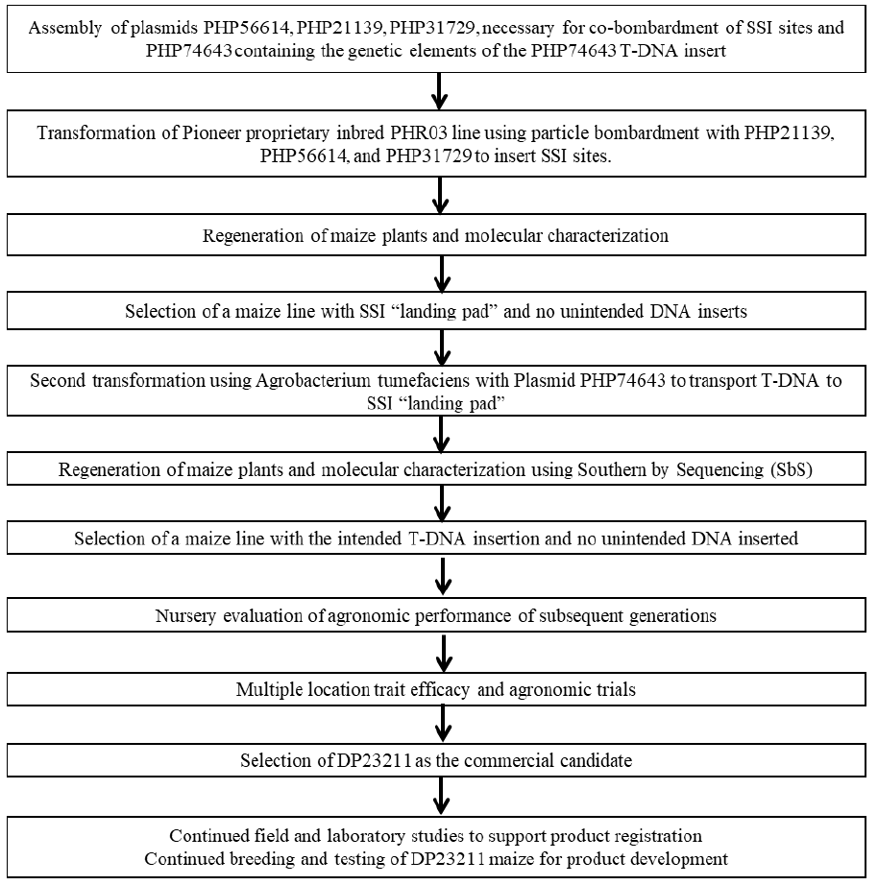

9 Appendix 2
PHP56614 and PHP74643 plasmid maps
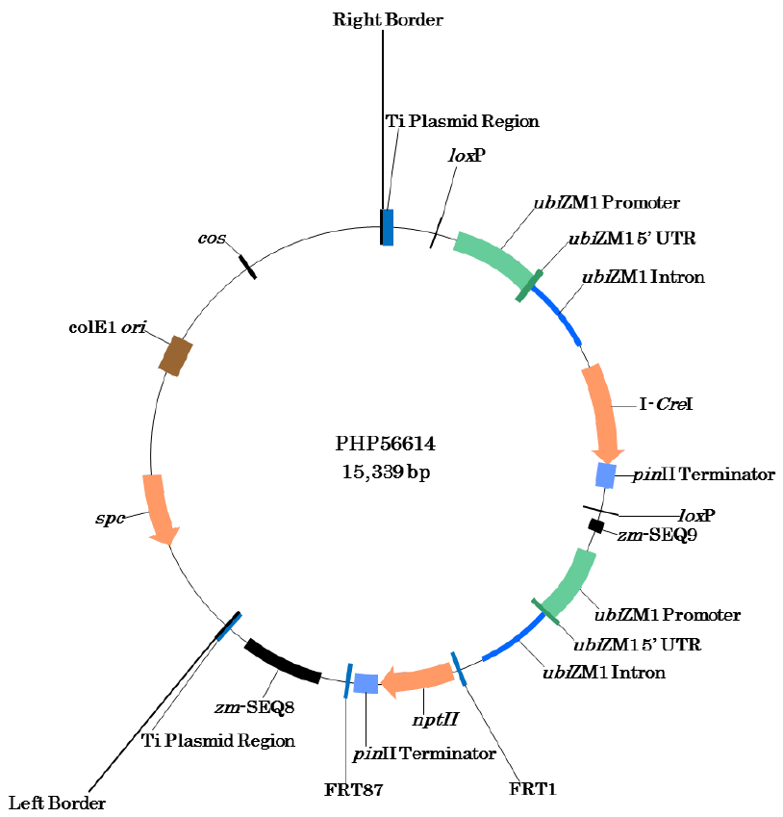
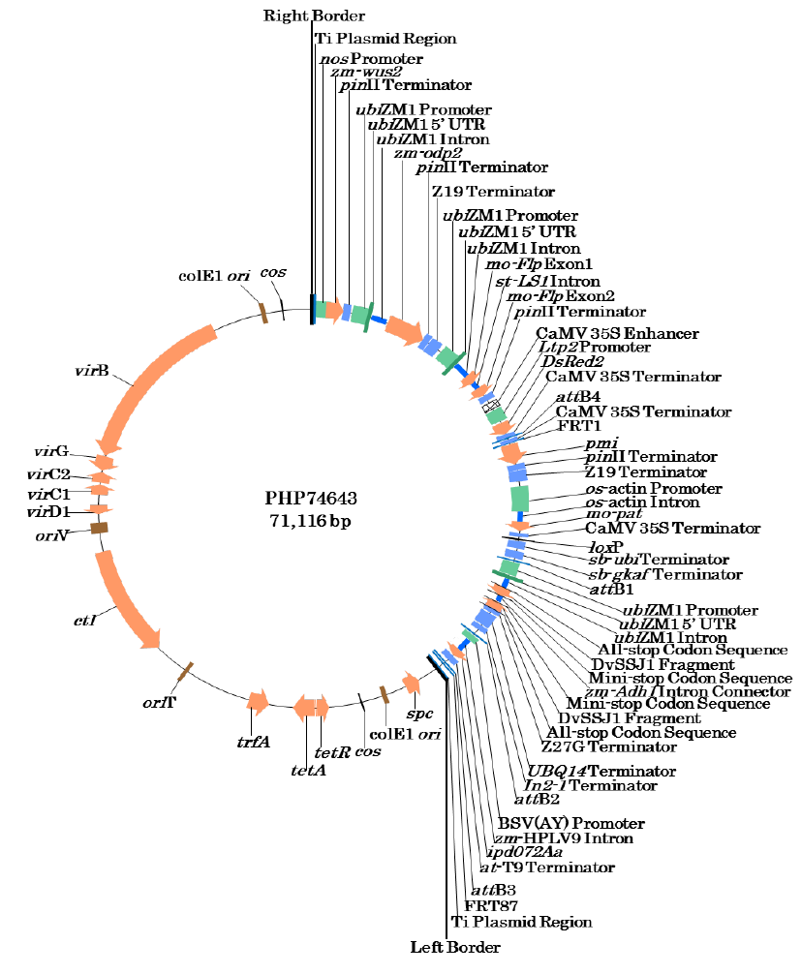

Million Tons
For more information please see USDA Economic Research Service: http://www.ers.usda.gov/data-products/adoption-of-genetically-engineered-crops-in-the-us.aspx
USDA Grain Report, CA14062, 2014: https://apps.fas.usda.gov/newgainapi/api/Report/DownloadReportByFileName?fileName=Agricultural%20Biotechnology%20Annual_Ottawa_Canada_7-14-2014
COMPARE database; http://comparedatabase.org/database/
Field trial sites for testing protein expression levels were in the following US states – Iowa, Illinois, Indiana, Minnesota and Pennsylvania; and the following state in Canada – Ontario.
FSANZ application handbook, Chapter 3.5.1 B.2 page 105 https://www.foodstandards.gov.au/code/changes/Pages/applicationshandbook.aspx
FSANZ application handbook, Chapter 3.5.1 B.2 page 105 https://www.foodstandards.gov.au/code/changes/Pages/applicationshandbook.aspx
The location of the eight field trial sites: two sites in Illinois US, one site in Iowa, Indiana, Minnesota, Pennsylvania, and Texas US, one site in Ontario Canada.

